**Chapter 4: Software Design**

**4.1 Purpose**

This chapter is to give the development team aware of what the system architecture is, and how they should be implemented. This chapter consists of:

* Architecture overview
* Component diagram
* Detailed design
* Detailed description of components
* Database design

**4.2 Architecture Overview**

**4.2.1 System Architecture**

**4.2.1.1 Diagram**

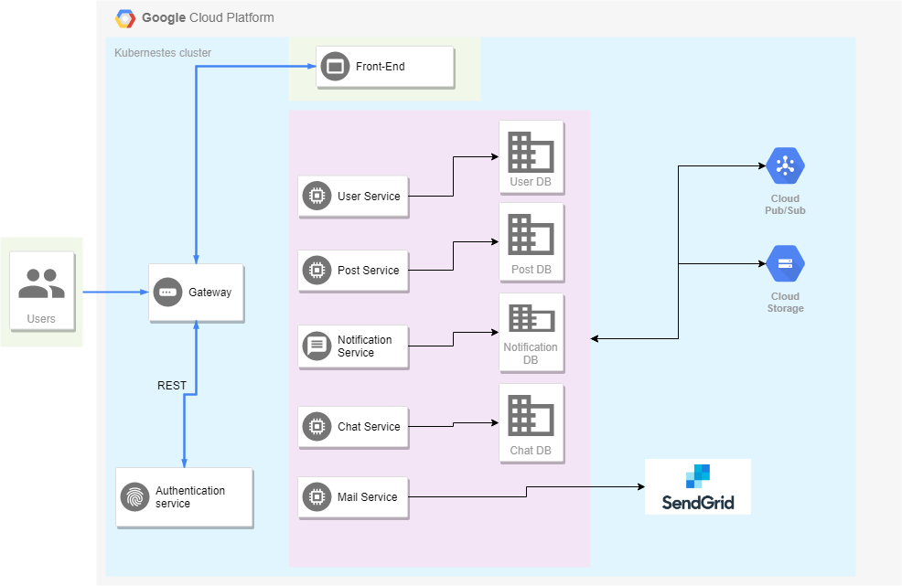

*Figure 4-1: TripSharing System Architecture*

**4.2.2 System Architecture Explanation**

The entire project will be deployed on Google Cloud. We aim at delivering a secured,

responsive, and highly available system. In the following section, we will explain the function and mechanism of each unit in the system architecture design.

**4.2.2.1 Google Cloud Storage**



*Figure 4-2: Google cloud storage*

**Google Cloud Storage** is a web-services interface data storage & retrieval. We use Google Cloud Storage for storing images.

**4.2.2.2 Google Cloud Pub/Sub**



*Figure 4-3: Google cloud pub/sub*

**Cloud Pub/Sub** is a fully-managed real-time messaging service that allows you to send and receive messages between independent applications. We use Cloud Pub/Sub to handle communication among microservices.

**4.2.2.3 Docker**



*Figure 4-4: Docker*

**Docker** is a tool designed to make it easier to create, deploy, and run applications by using containers. Containers allow a developer to package up an application with all of the parts it needs, such as libraries and other dependencies, and ship it all out as one package. We use Docker to build and push images to Docker Hub for deployment and testing.

**4.2.2.4 Google Cloud**



*Figure 4-5: Google cloud*

**Google Cloud Platform** is a suite of cloud computing services that runs on the same infrastructure that Google uses internally for its end-user products. Alongside a set of management tools, it provides a series of modular cloud services including computing, data storage, data analytics and machine learning. Apart from Cloud Storage and Pub/Sub mentioned above, the main part of operation lies in the usage of the Kubernetes Engine that supports easy deployment and scaling from docker images.

**4.2.2.5 Nginx**



*Figure 4-6: Nginx*

**NGINX** is a free, open-source, high-performance HTTP server and reverse proxy, as well as an IMAP/POP3 proxy server. NGINX is known for its high performance, stability, rich feature set, simple configuration, and low resource consumption. We use Nginx to serve the frontend service of TripSharing.

**4.2.2.6 MongoDB**



*Figure 4-7: MongoDB*

**MongoDB** is an open source database and is the leading NoSQL database, used by millions of people. MongoDB is written in C ++. In addition, MongoDB is a cross-platform database, operating on the concepts of Collection and Document, it provides high performance, high availability and easy scalability.

**4.2.2.7 Angular 7**



*Figure 4-8: Angular 7*

**Angular 7** is the library of Angular, a framework created by Google that supports Flat & Material design website. Supporting Progressive Web Application, this framework has become very popular nowadays.

**4.2.2.8 Angular Material**



*Figure 4-9: Angular Material*

**Angular Material** is a great JavaScript framework for creating themed UI components that ignite good user experience.

**4.2.2.9 C#**



*Figure 4-10: C# (C Sharp)*

**C#** is a general object-oriented programming (OOP) language for networking and Web development. C# is specified as a common language infrastructure (CLI) language. Its NET framework promotes multiple Web technologies. We use C# to write back-end code.

**4.2.2.10 ASP.NET Core**



*Figure 4-11: ASP.NET Core*

**ASP.NET Core** is a cross-platform, high-performance, open-source framework for building modern, cloud-based, Internet-connected applications. We use ASP.NET Core to write back-end API services.

**4.2.2.11 ASP.NET Core SignalR**



*Figure 4-12: Signal R*

**ASP.NET Core SignalR** is an open-source library that simplifies adding real-time web functionality to apps. Real-time web functionality enables server-side code to push content to clients instantly. We user SignalR for chat and notification.

**4.2.2.12 SendGrid**



*Figure 4-13: SendGrid*

**SendGrid** is a platform for transactional and marketing email. We use SendGrid to send emails to users for verification.

**4.3 Design of TripSharing System**

**4.3.1 Architecture Layers Design**

**4.3.1.1 API Layer Design**

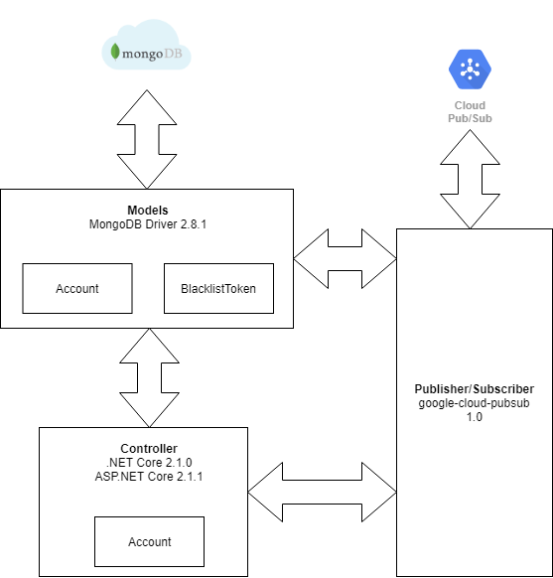

*Figure 4-14: Identity Provider Design*

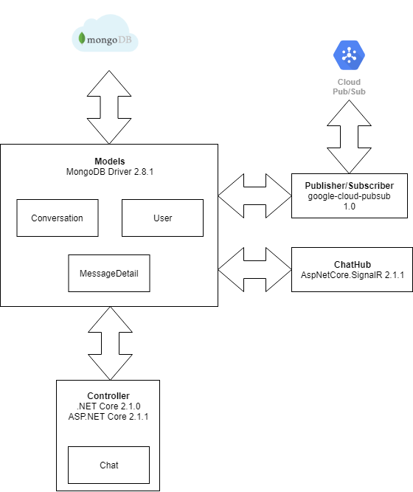

*Figure 4-15: Conversation Service Design*

**4.3.2 Database Design**

**4.3.2.1 Explanation of database decision**

**4.3.2.1.1 Operational Database – MongoDB**



MongoDB is our first choice for storing operational data because it has powerful features that suit our needs:

* The very basic feature of MongoDB is that it is a schema-less database. No schema migrations anymore.
* Stores the data in the form of BSON (Binary JSON), ruby hashes etc., helps to store the data in a very rich way while being capable of holding arrays and other documents.
* Reliability, Performance & Ease of Use.

**4.3.2.2 Database Diagram**

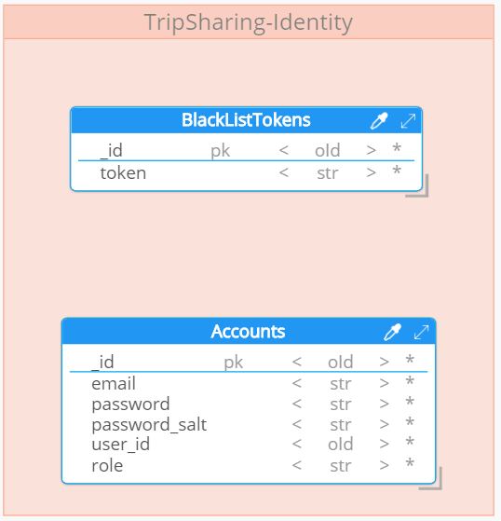

*Figure 4-16: Identity Provider Database Design*

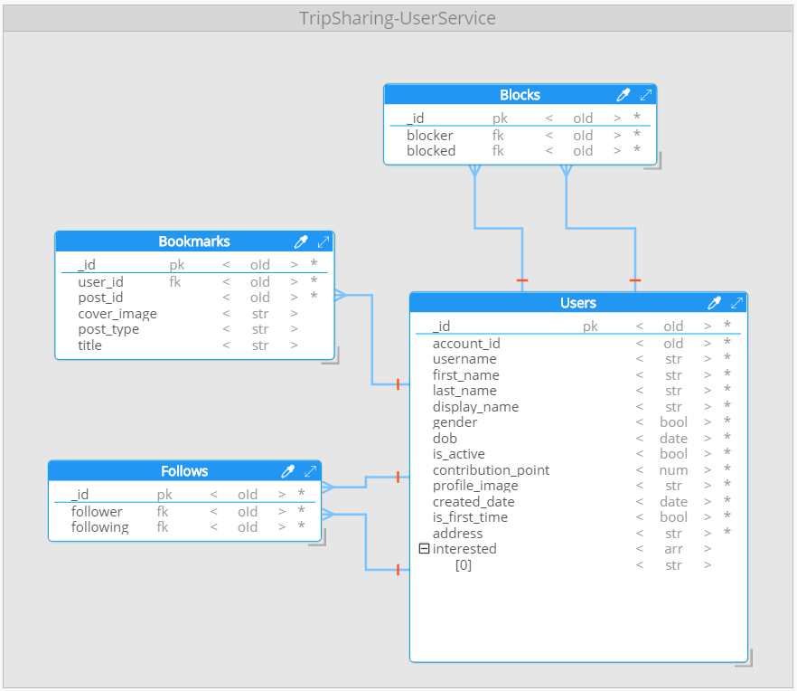

*Figure 4-17: User Database Design*

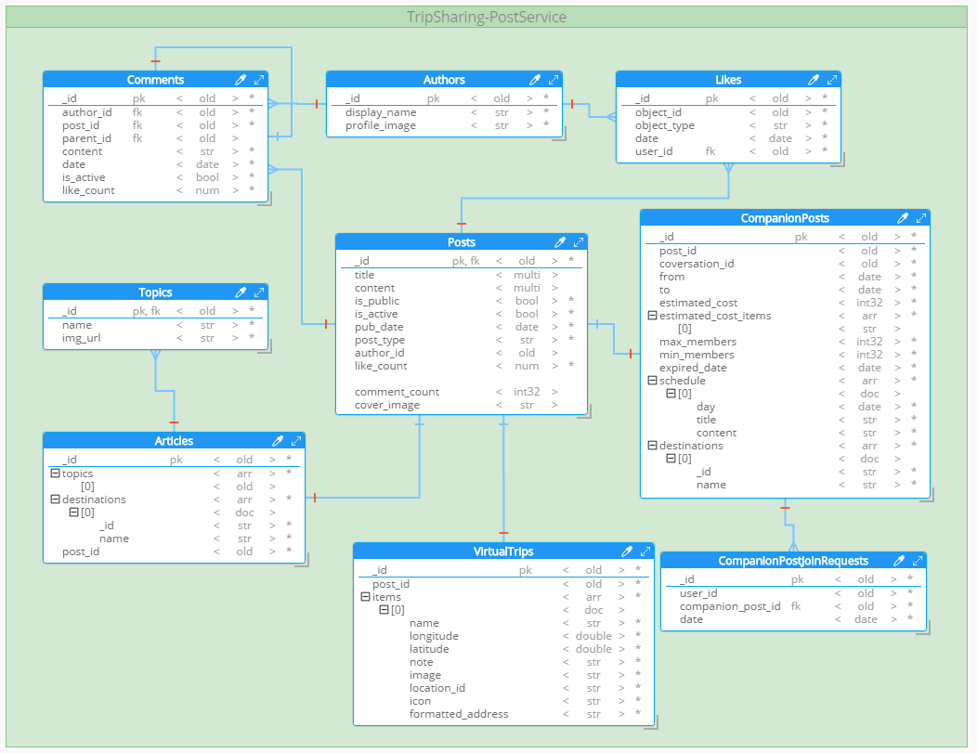

*Figure 4-18: Post Database Design*

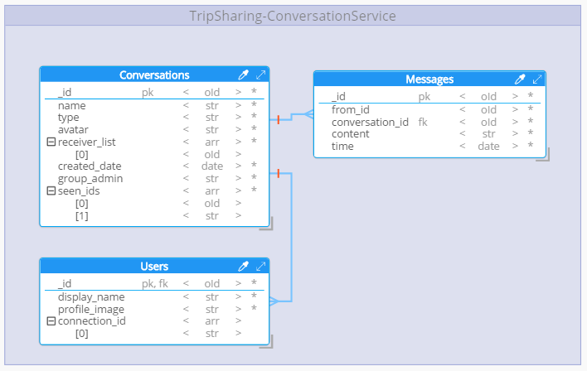

*Figure 4-19: Conversation Database Design*

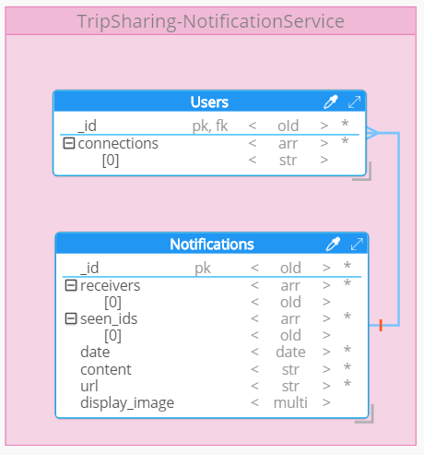

*Figure 4-20: Notification Database Design*

**4.3.2.3 Data Dictionary**

*4.3.2.3.1 TripSharing – Operational database*

*4.3.2.3.1.1 Entities*

|  |  |  |  |  |
| --- | --- | --- | --- | --- |
| **No** | **Entity Name** | **Description** | **Alias** | **Occurrence** |
| 1 | Users | General term describing  a user profiles. |  | Each user has one account.  Each user has many interested topics. |
| 2 | Follows | General term describing a follow relation between users. |  | Each user has many followers.  Each user can follow many others. |
| 3 | Blocks | General term describing a block relation between users. |  | Each user can block many others. |
| 4 | Bookmarks | General term describing bookmarks of each user. |  | Each user has many bookmarks. |
| 5 | Accounts | General term describing a registered account of a user. |  | Each account belongs to one user.  Each account has one email. |
| 6 | Posts | General term describing a post. |  | Each post has one type (companion, article or virtual trip).  Each post has many comments.  Each post has many likes.  Each post has one author. |
| 7 | Likes | General term describing a “like” action of user. |  | Each user can like many posts or comments. |
| 8 | Comments | General term describing comments of user. |  | Each user has many comments.  Each comment has many child comments. |
| 9 | Author | General term describing a user who is author of a post. |  | Each user has many posts. |
| 10 | Articles | General term describing an article type of post. |  | Each article has one post.  Each article has many topics.  Each article has many destinations. |
| 11 | Topics | General term describing a topic of an article. |  |  |
| 12 | VirtualTrips | General term describing a virtual trip type of post. |  | Each virtual trip has many items, each item contains destination information. |
| 13 | CompanionPosts | General term describing a companion type of post. |  | Each companion post has one conversation. |
| 14 | CompanionJoinRequest | General term describing a request to join companion. |  |  |
| 15 | Notifications | General term describing a notification. |  | Each notification has many receivers(user). |
| 16 | Conversations | General term describing a conversation between two or more users. |  | Each conversation has many receivers(user).  Each conversation has many messages. |
| 17 | Messages | General term describing a message send to conversation. |  | Each message has one sender(user). |
| 18 | BlackListTokens | General term describing a token that no longer valid |  | Token will be moved to black list if user sign-out. |

*4.3.2.3.1.2 Attributes*

|  |  |  |  |  |  |
| --- | --- | --- | --- | --- | --- |
| **No** | **Entities Name** | **Field Name** | **Data Type** | **Description** | **Not Null** |
| 1 | Users | _id | Object Id |  | Yes |
| account_id | Object Id |  | Yes |
| username | String |  | Yes |
| first_name | String |  | Yes |
| last_name | String |  | Yes |
| display_name | String |  | Yes |
| interested | Array | User interested topic | Yes |
| gender | Boolean |  | Yes |
| dob | Date |  | Yes |
| is_active | Boolean | Whether user is banned. | Yes |
| contribution_point | Integer |  | Yes |
| profile_image | String |  | Yes |
| created_date | Date |  | Yes |
| is_first_time | Boolean | Whether user is first time sign-in. | Yes |
| address | String |  | Yes |
| 2 | Accounts | _id | Object Id |  | Yes |
| email | String |  | Yes |
| password | String | Encrypted password | Yes |
| password_salt | string |  | Yes |
| user_id | Object Id |  | Yes |
| role | String | Role of user | Yes |
| 3 | BlackListTokens | _id | Object Id |  | Yes |
| token | String |  | Yes |
| 4 | Follows | _id | Object Id |  | Yes |
| follower | Object Id |  | Yes |
| following | Object Id |  | Yes |
| 5 | Blocks | _id | Object Id |  | Yes |
| blocker | Object Id |  | Yes |
| blocked | Object Id |  | Yes |
| 6 | Bookmarks | _id | Object Id |  | Yes |
| user_id | Object Id |  | Yes |
| post_id | Object Id |  | Yes |
| title | String |  | Yes |
| cover_image | String |  | Yes |
| post_type | String |  | Yes |
| title | String |  | Yes |
| 7 | Authors | _id | Object Id |  | Yes |
| display_name | String |  | Yes |
| profile_image | String |  | Yes |
| 8 | Posts | _id | Object Id |  | Yes |
| title | String |  | Yes |
| content | String |  | Yes |
| is_public | Boolean | Whether post is show for another user or just author. | Yes |
| is_active | Boolean | Whether post is banned. | Yes |
| pub_date | Date |  | Yes |
| post_type | String |  | Yes |
| author_id | Object Id |  | Yes |
| like_count | Integer |  | Yes |
| comment_count | Integer |  | Yes |
| cover_image | String |  | Yes |
| 9 | Articles | _id | Object Id |  | Yes |
| topics | Array | An array of string to store topics. | Yes |
| destinations | Array | An array of object store information about destinations on the trip. | Yes |
| post_id | Object Id |  | Yes |
| 10 | Topics | _id | Object Id |  | Yes |
| name | String |  | Yes |
| img_url | String |  | Yes |
| 11 | VirtualTrips | _id | Object Id |  | Yes |
| post_id | Object Id |  | Yes |
| items | Array | List of object store information about destinations on the trip. | Yes |
| 12 | CompanionPosts | _id | Object Id |  | Yes |
| post_id | Object Id |  | Yes |
| conversation_id | Object Id |  | Yes |
| from | Date |  | Yes |
| to | Date |  | Yes |
| estimated_cost | Double |  | Yes |
| estimated_cost_item | Array |  | Yes |
| max_members | Integer |  | Yes |
| min_members | Integer |  | Yes |
| expired_date | Date |  | Yes |
| schedule | Array | List of note what to do on the trip, added by user. | Yes |
| destinations | Array | List of object store information about destinations on the trip. | Yes |
| 13 | CompanionPostJoinRequest | _id | Object Id |  | Yes |
| user_id | Object Id |  | Yes |
| companion_post_id | Object Id |  | Yes |
| date | Date |  | Yes |
| 14 | Likes | _id | Object Id |  | Yes |
| object_id | Object Id |  | Yes |
| object_type | String | Whether user like post or comment | Yes |
| date | Date |  | Yes |
| user_id | Object Id |  | Yes |
| 15 | Comments | _id | Object Id |  | Yes |
| Author_id | Object Id |  | Yes |
| Post_id | Object Id |  | Yes |
| Parent_id | Object Id |  | No |
| Content | String |  | Yes |
| Date | Date |  | Yes |
| Is_active | Boolean | Whether comment is deleted | Yes |
| Like_count | Integer |  | Yes |
| 16 | Conversation | _id | Object Id |  | Yes |
| name | String |  | Yes |
| type | String |  | Yes |
| receiver_list | Array | List of users receive message from conversation | Yes |
| last_message | Object |  | Yes |
| 17 | Messages | _id | Object Id |  | Yes |
| from_id | Object Id |  | Yes |
| conversation_id | Object Id |  | Yes |
| content | String |  | Yes |
| time | Date |  | Yes |
| seen_id | Object Id | List of users already see the message. | Yes |
| 18 | Notifications | _id | Object Id |  | Yes |
| receivers | Array | List of users receive notification. | Yes |
| seen_ids | Array | List of users already see the notification. | Yes |
| date | Date |  | Yes |
| content | String |  | Yes |
| url | String |  | Yes |
| display_image | String |  | Yes |

**4.3.3 Common Design**

**4.3.3.1 Microservice Architecture**

*4.3.3.1.1 What is Microservice?*

Microservices is a software architecture style in which complex applications are composed of small, independent processes communicating with each other using language-agnostic APIs. These services are small, highly decoupled and focus on doing a small task, facilitating a modular approach to system-building.

* + - * 1. *Philosophy*

Philosophy of Microservices architecture essentially equals the Unix philosophy of "Do one thing and do it well". It is described as follows:

* The services are small - fine-grained to perform a single function.
* The organization culture should embrace automation of deployment and testing. This eases the burden on management and operations.
* The culture and design principles should embrace failure and faults, similar to anti-fragile systems.
* Each service is elastic, resilient, composable, minimal, and complete.
  + - * 1. *Microservice in TripSharing*

In TripSharing, we implement Microservices as the following things:

* The overall system is divided into small microservices according to their domain of operation.
* Deployment of services is done by using Kubernetes.
* Use third-party services: SendGrid for sending mail.
  + 1. **Detail Design**
       1. **Sign-up**

**Screen design**

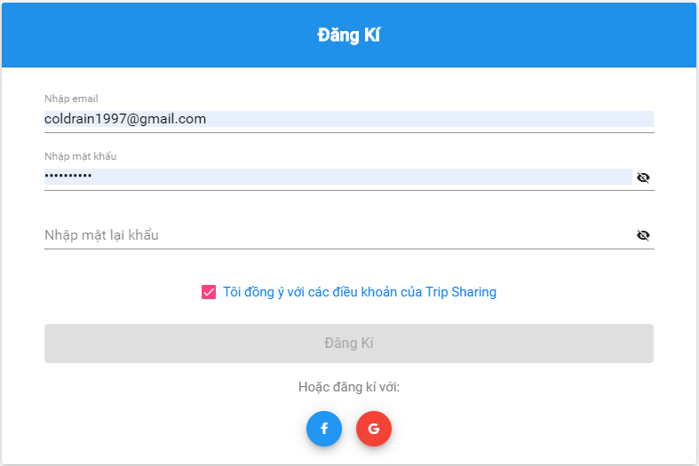

*Figure 4-21: Sign up screen*

**Class Diagram**

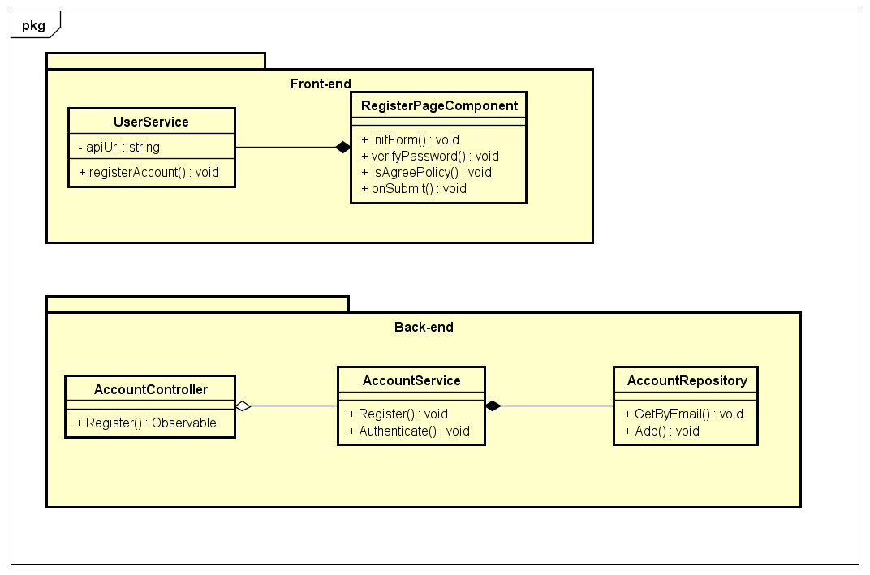

*Figure 4-22: Sign-up Class Diagram*

**Class Specification**

***RegisterPageComponent***

|  |  |  |  |
| --- | --- | --- | --- |
| **RegisterPageComponent** | | | |
| Physical address | src\app\pages\register-page\ register-page.component.ts | | |
| Base Class | Class | | |
| **Attributes** | | | |
|  |  |  |  |
| **Operations** | | | |
| No | Name | Return Type | Description |
| 1 | initForm | void | Create sign-up form |
| 2 | verifyPassword | void | Verify if re-enter password match |
| 3 | isAgreePolicy | void | Check if guest agree with policy |
| *4* | *onSubmit* | *void* | *Submit register form* |

***UserService***

|  |  |  |  |
| --- | --- | --- | --- |
| **UserService** | | | |
| Physical address | src\app\core\services\user-service\user.service.ts | | |
| Base Class | Class | | |
| **Attributes** | | | |
| No | Name | Type | Description |
| 1 | apiURL | String |  |
| **Operations** | | | |
| No | Name | Return Type | Description |
| 1 | registerAccount | void |  |

***AccountController***

|  |  |  |  |
| --- | --- | --- | --- |
| **AccountController** | | | |
| Physical address | \src\Services\IdentityProvider\IdentityProvider\Controllers\  AccountController.cs | | |
| Base Class | Class | | |
| **Attributes** | | | |
| No | Name | Type | Description |
|  |  |  |  |
| **Operations** | | | |
| No | Name | Return Type | Description |
| 1 | Register | Observable |  |

***AccountService***

|  |  |  |  |
| --- | --- | --- | --- |
| **AccountService** | | | |
| Physical address | \src\Services\IdentityProvider\IdentityProvider\Services\AccountService.cs | | |
| Base Class | Class | | |
| **Attributes** | | | |
| No | Name | Type | Description |
|  |  |  |  |
| **Operations** | | | |
| No | Name | Return Type | Description |
| 1 | Register | void |  |
| 2 | Authenticate | void |  |

***AccountRepository***

|  |  |  |  |
| --- | --- | --- | --- |
| **AccountRepository** | | | |
| Physical address | \src\Services\IdentityProvider\IdentityProvider\Repositories\AccountRepository.cs | | |
| Base Class | Class | | |
| **Attributes** | | | |
| No | Name | Type | Description |
|  |  |  |  |
| **Operations** | | | |
| No | Name | Return Type | Description |
| 1 | GetByEmail | void |  |
| 2 | Add | void |  |

**Sequence Diagram**

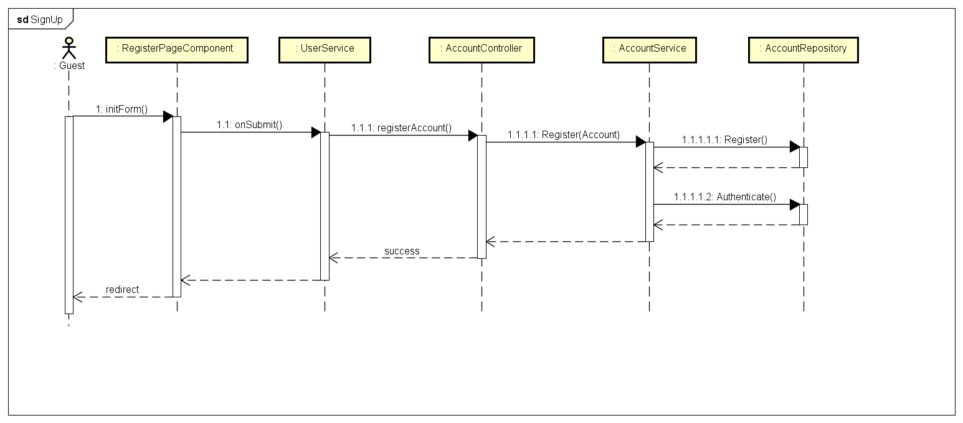

*Figure 4-23: Sign-up Sequence Diagram*

* + - 1. **Google Sign-in**

**Screen Design**

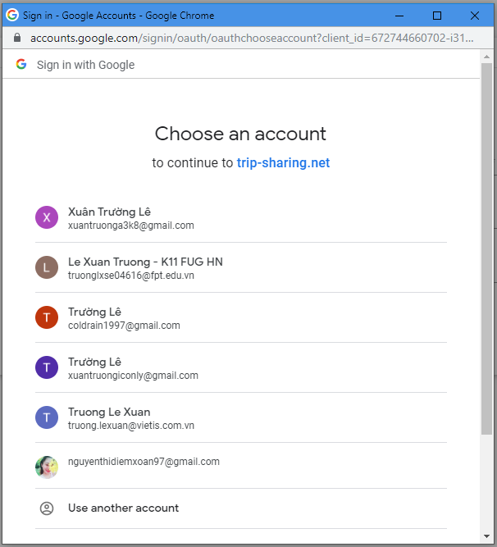

*Figure 4-24: Google Sign in Screen Design*

**Class Diagram**

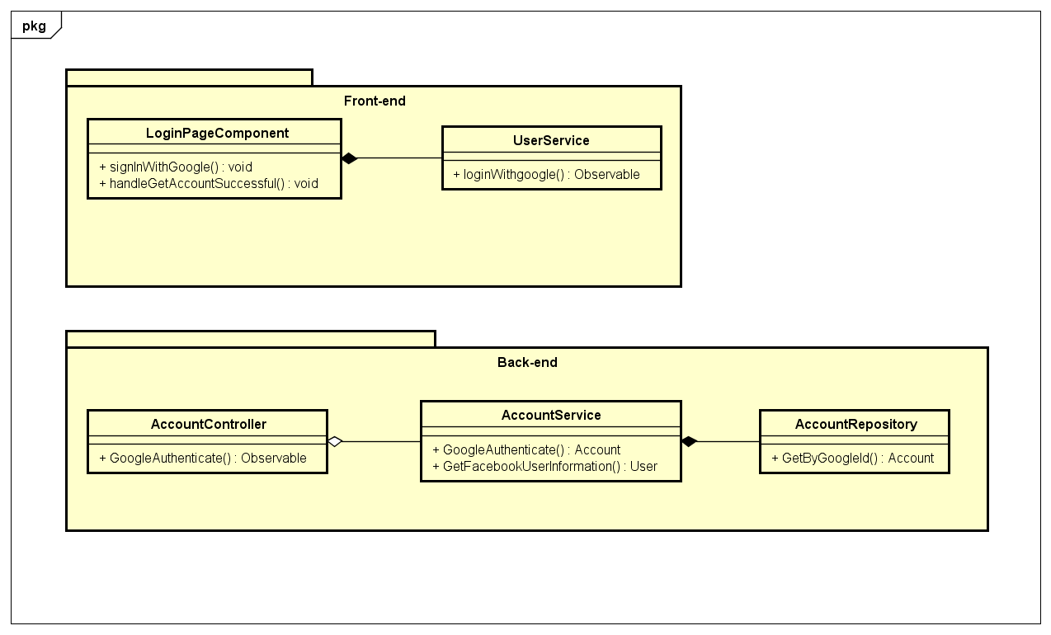

*Figure 4-25: Google Sign-in Class Diagram*

**Class Specification**

***LoginPageComponent***

|  |  |  |  |
| --- | --- | --- | --- |
| **LoginPageComponent** | | | |
| Physical address | src\app\pages\login-page\login-page.component.ts | | |
| Base Class | Class | | |
| **Attributes** | | | |
|  |  |  |  |
| **Operations** | | | |
| No | Name | Return Type | Description |
| 1 | signInWithGoogle | void |  |
| 2 | handleGetAccountSuccessful | void |  |

***UserService***

|  |  |  |  |
| --- | --- | --- | --- |
| **UserService** | | | |
| Physical address | src\app\core\services\user-service\user.service.ts | | |
| Base Class | Class | | |
| **Attributes** | | | |
| No | Name | Type | Description |
| 1 | apiURL | String |  |
| **Operations** | | | |
| No | Name | Return Type | Description |
| 1 | loginWithGoogle | Observable |  |

***AccountController***

|  |  |  |  |
| --- | --- | --- | --- |
| **AccountController** | | | |
| Physical address | \src\Services\IdentityProvider\IdentityProvider\Controllers\  AccountController.cs | | |
| Base Class | Class | | |
| **Attributes** | | | |
| No | Name | Type | Description |
|  |  |  |  |
| **Operations** | | | |
| No | Name | Return Type | Description |
| 1 | GoogleAuthenticate | Observable |  |

***AccountService***

|  |  |  |  |
| --- | --- | --- | --- |
| **AccountService** | | | |
| Physical address | \src\Services\IdentityProvider\IdentityProvider\Services\AccountService.cs | | |
| Base Class | Class | | |
| **Attributes** | | | |
| No | Name | Type | Description |
|  |  |  |  |
| **Operations** | | | |
| No | Name | Return Type | Description |
| 1 | GoogleAuthenticate | void |  |
| 2 | GetGoogleUserInformation | User |  |

***AccountRepository***

|  |  |  |  |
| --- | --- | --- | --- |
| **AccountRepository** | | | |
| Physical address | \src\Services\IdentityProvider\IdentityProvider\Repositories\AccountRepository.cs | | |
| Base Class | Class | | |
| **Attributes** | | | |
| No | Name | Type | Description |
|  |  |  |  |
| **Operations** | | | |
| No | Name | Return Type | Description |
| 1 | GetByGoogleId | Account |  |

**Sequence Diagram**

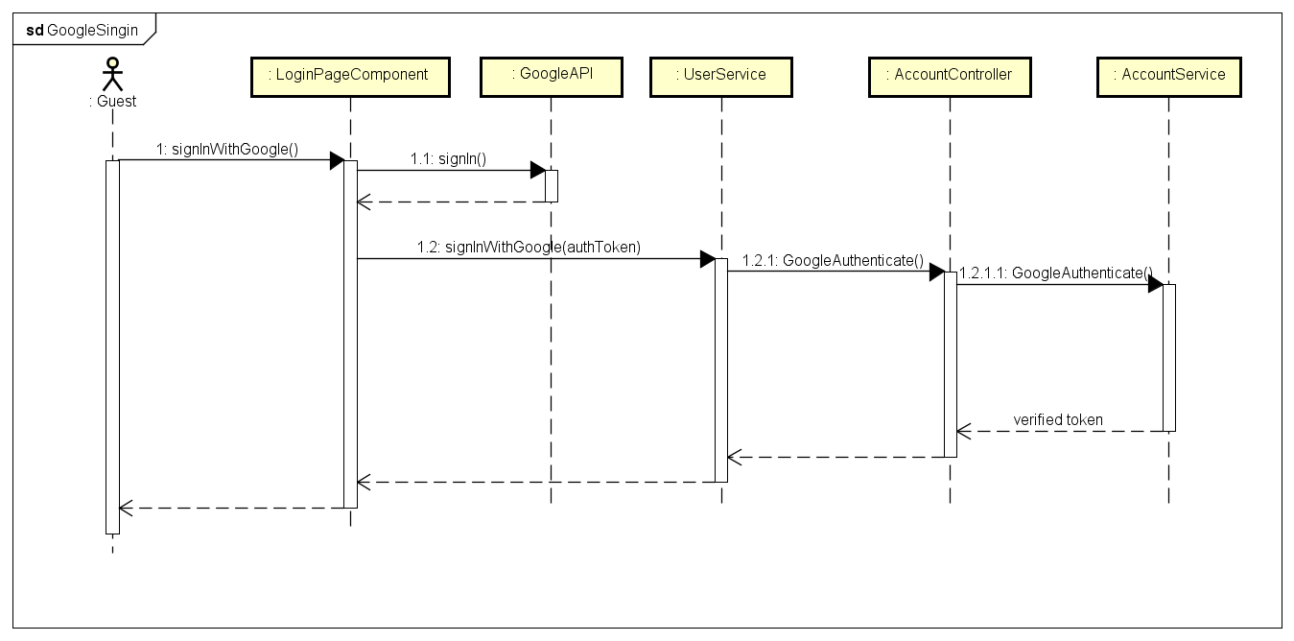

*Figure 4-26: Google Sign-in Sequence Diagram*

* + - 1. **Facebook Sign-in**

**Screen Design**

**Class Diagram**

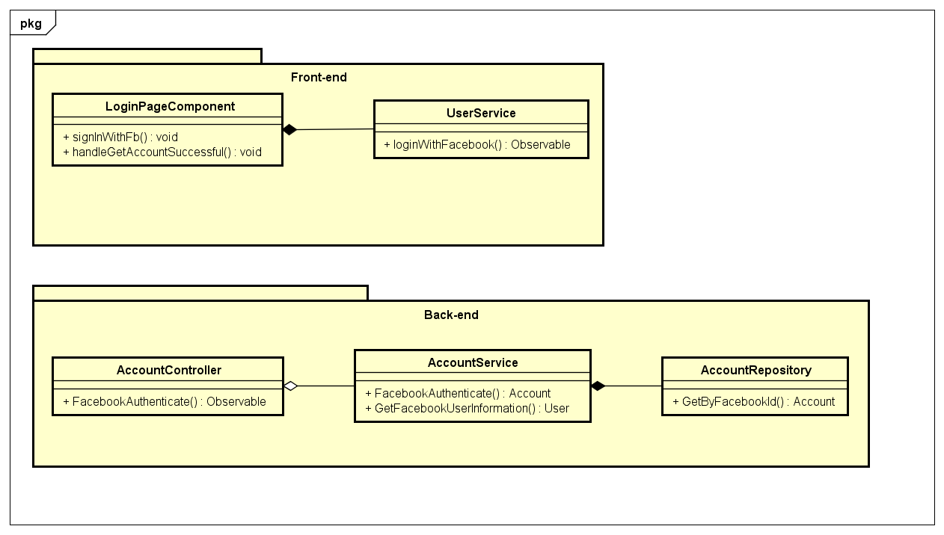

*Figure 4-27: Facebook Sign-in Class Diagram*

**Class Specification**

***LoginPageComponent***

|  |  |  |  |
| --- | --- | --- | --- |
| **LoginPageComponent** | | | |
| Physical address | src\app\pages\login-page\login-page.component.ts | | |
| Base Class | Class | | |
| **Attributes** | | | |
|  |  |  |  |
| **Operations** | | | |
| No | Name | Return Type | Description |
| 1 | signInWithFb | void |  |
| 2 | handleGetAccountSuccessful | void |  |

***UserService***

|  |  |  |  |
| --- | --- | --- | --- |
| **UserService** | | | |
| Physical address | src\app\core\services\user-service\user.service.ts | | |
| Base Class | Class | | |
| **Attributes** | | | |
| No | Name | Type | Description |
| 1 | apiURL | String |  |
| **Operations** | | | |
| No | Name | Return Type | Description |
| 1 | loginWithFacebook | Observable |  |

***AccountController***

|  |  |  |  |
| --- | --- | --- | --- |
| **AccountController** | | | |
| Physical address | \src\Services\IdentityProvider\IdentityProvider\Controllers\  AccountController.cs | | |
| Base Class | Class | | |
| **Attributes** | | | |
| No | Name | Type | Description |
|  |  |  |  |
| **Operations** | | | |
| No | Name | Return Type | Description |
| 1 | FacebookAuthenticate | Observable |  |

***AccountService***

|  |  |  |  |
| --- | --- | --- | --- |
| **AccountService** | | | |
| Physical address | \src\Services\IdentityProvider\IdentityProvider\Services\AccountService.cs | | |
| Base Class | Class | | |
| **Attributes** | | | |
| No | Name | Type | Description |
|  |  |  |  |
| **Operations** | | | |
| No | Name | Return Type | Description |
| 1 | FacebookAuthenticate | void |  |
| 2 | GetFacebookUserInformation | User |  |

***AccountRepository***

|  |  |  |  |
| --- | --- | --- | --- |
| **AccountRepository** | | | |
| Physical address | \src\Services\IdentityProvider\IdentityProvider\Repositories\AccountRepository.cs | | |
| Base Class | Class | | |
| **Attributes** | | | |
| No | Name | Type | Description |
|  |  |  |  |
| **Operations** | | | |
| No | Name | Return Type | Description |
| 1 | GetByFacebookId | Account |  |

**Sequence Diagram**

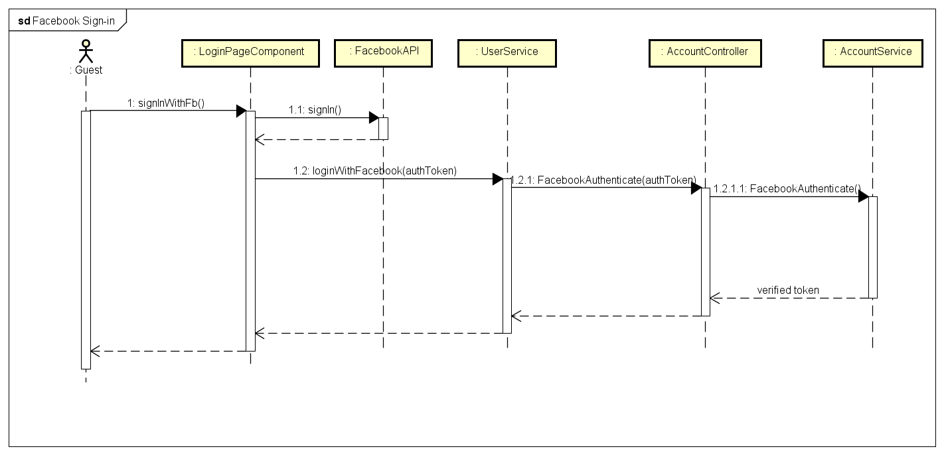

*Figure 4-28: Facebook Sign-in Sequence Diagram*

* + - 1. **Normal Sign-in**

**Screen Design**

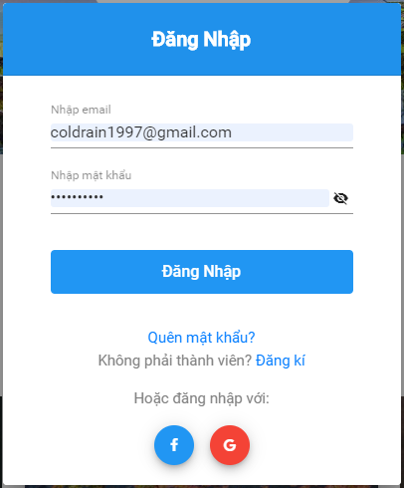

*Figure 4-29: Normal Sign-in Screen Design*

**Class Diagram**

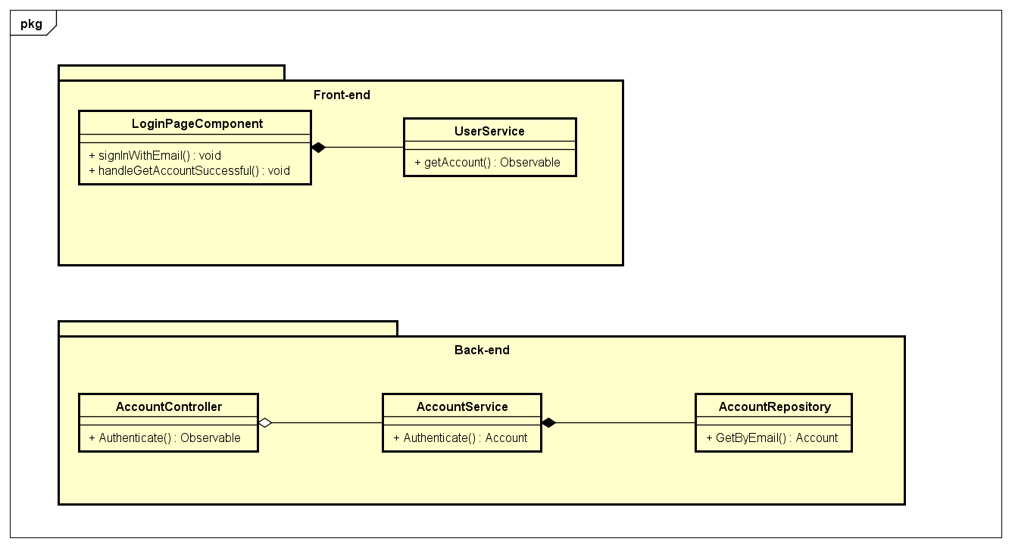

*Figure 4-30: Normal Sign-in Class Diagram*

**Class Specification**

***LoginPageComponent***

|  |  |  |  |
| --- | --- | --- | --- |
| **LoginPageComponent** | | | |
| Physical address | src\app\pages\login-page\login-page.component.ts | | |
| Base Class | Class | | |
| **Attributes** | | | |
|  |  |  |  |
| **Operations** | | | |
| No | Name | Return Type | Description |
| 1 | signInWithEmail | void |  |
| 2 | handleGetAccountSuccessful | void |  |

***UserService***

|  |  |  |  |
| --- | --- | --- | --- |
| **UserService** | | | |
| Physical address | src\app\core\services\user-service\user.service.ts | | |
| Base Class | Class | | |
| **Attributes** | | | |
| No | Name | Type | Description |
|  |  |  |  |
| **Operations** | | | |
| No | Name | Return Type | Description |
| 1 | getAccount | Observable |  |

***AccountController***

|  |  |  |  |
| --- | --- | --- | --- |
| **AccountController** | | | |
| Physical address | \src\Services\IdentityProvider\IdentityProvider\Controllers\  AccountController.cs | | |
| Base Class | Class | | |
| **Attributes** | | | |
| No | Name | Type | Description |
|  |  |  |  |
| **Operations** | | | |
| No | Name | Return Type | Description |
| 1 | Authenticate | Observable |  |

***AccountService***

|  |  |  |  |
| --- | --- | --- | --- |
| **AccountService** | | | |
| Physical address | \src\Services\IdentityProvider\IdentityProvider\Services\AccountService.cs | | |
| Base Class | Class | | |
| **Attributes** | | | |
| No | Name | Type | Description |
|  |  |  |  |
| **Operations** | | | |
| No | Name | Return Type | Description |
| 1 | Authenticate | void |  |

***AccountRepository***

|  |  |  |  |
| --- | --- | --- | --- |
| **AccountRepository** | | | |
| Physical address | \src\Services\IdentityProvider\IdentityProvider\Repositories\AccountRepository.cs | | |
| Base Class | Class | | |
| **Attributes** | | | |
| No | Name | Type | Description |
|  |  |  |  |
| **Operations** | | | |
| No | Name | Return Type | Description |
| 1 | GetByEmail | Account |  |

**Sequence Diagram**

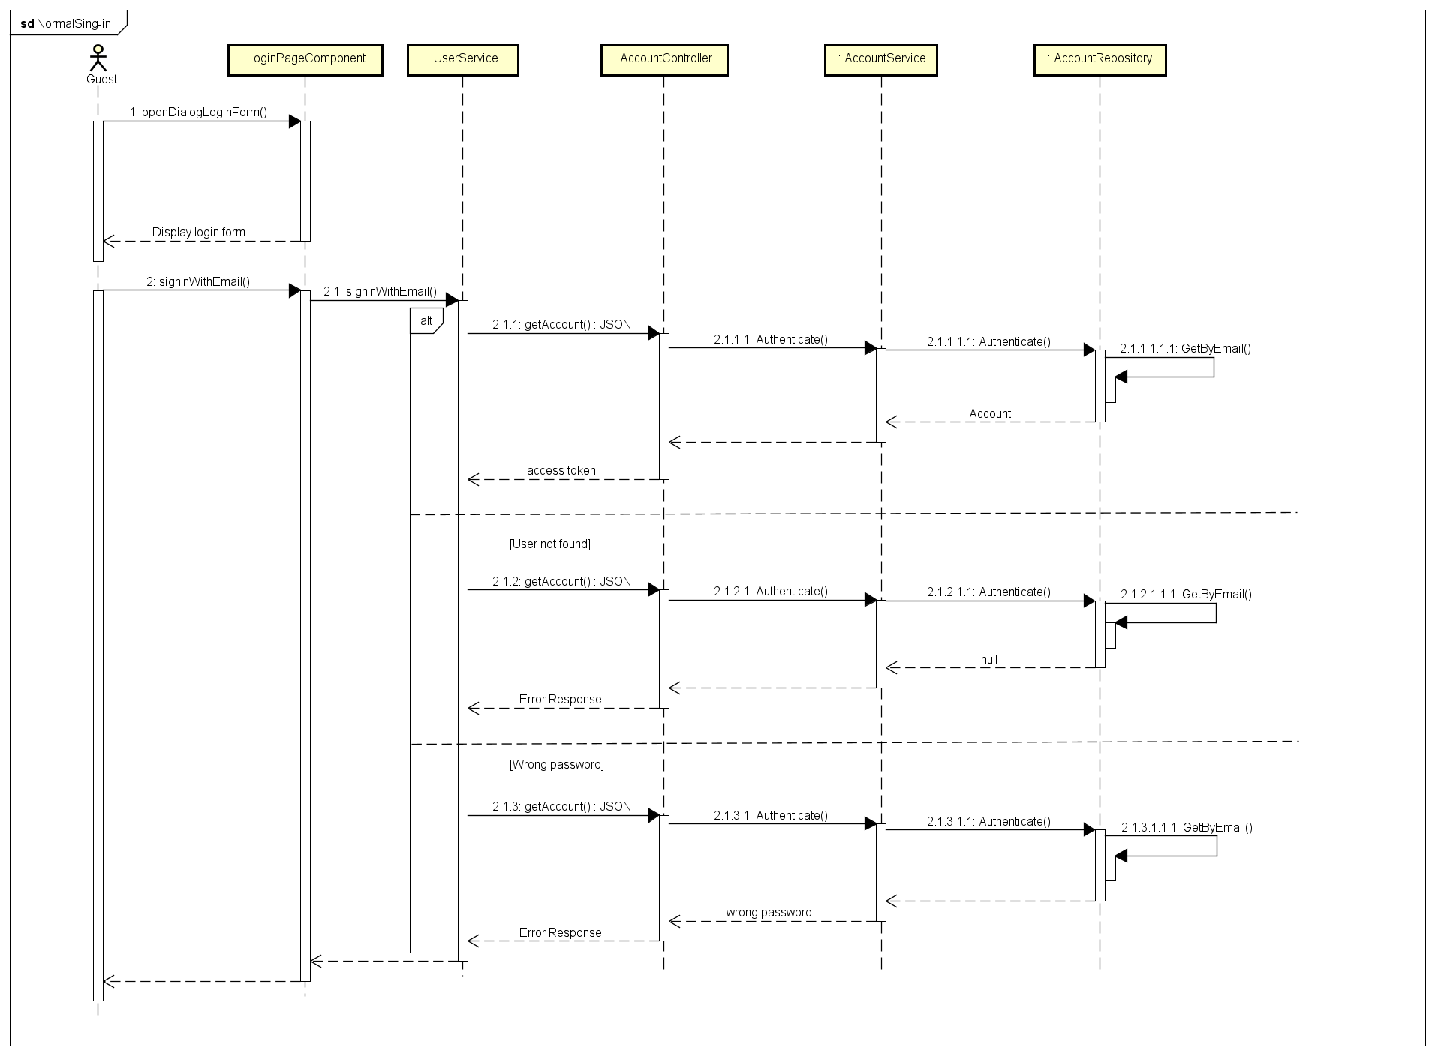

*Figure 4-31: Normal Sign-in Sequence Diagram*

* + - 1. **Forgot Password**

**Screen Design**

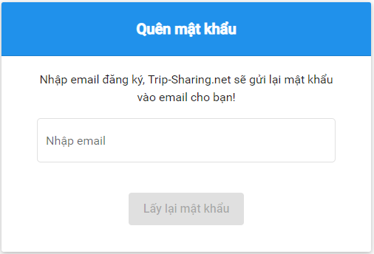

*Figure 4-32: Forgot Password Screen Design*

**Class Diagram**

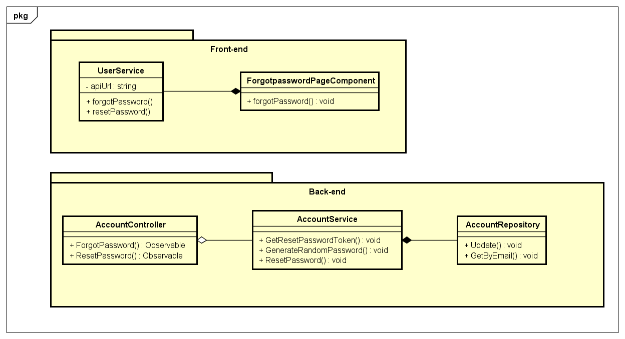

*Figure 4-33: Forgot Password Class Diagram*

**Class Specification**

***ForgotpasswordPageComponent***

|  |  |  |  |
| --- | --- | --- | --- |
| **ForgotpasswordPageComponent** | | | |
| Physical address | src\app\pages\login-page\forgotpassword-page.component.ts | | |
| Base Class | Class | | |
| **Attributes** | | | |
|  |  |  |  |
| **Operations** | | | |
| No | Name | Return Type | Description |
| 1 | forgotPassword |  |  |
| 2 | resetPassword |  |  |

***UserService***

|  |  |  |  |
| --- | --- | --- | --- |
| **UserService** | | | |
| Physical address | src\app\core\services\user-service\user.service.ts | | |
| Base Class | Class | | |
| **Attributes** | | | |
| No | Name | Type | Description |
| 1 | apiUrl |  |  |
| **Operations** | | | |
| No | Name | Return Type | Description |
| 1 | forgotPassword | Observable |  |

***AccountController***

|  |  |  |  |
| --- | --- | --- | --- |
| **AccountController** | | | |
| Physical address | \src\Services\IdentityProvider\IdentityProvider\Controllers\  AccountController.cs | | |
| Base Class | Class | | |
| **Attributes** | | | |
| No | Name | Type | Description |
|  |  |  |  |
| **Operations** | | | |
| No | Name | Return Type | Description |
| 1 | ForgotPassword | Observable |  |
| 2 | ResetPassword | Observable |  |

***AccountService***

|  |  |  |  |
| --- | --- | --- | --- |
| **AccountService** | | | |
| Physical address | \src\Services\IdentityProvider\IdentityProvider\Services\AccountService.cs | | |
| Base Class | Class | | |
| **Attributes** | | | |
| No | Name | Type | Description |
|  |  |  |  |
| **Operations** | | | |
| No | Name | Return Type | Description |
| 1 | GetResetPasswordToken | string |  |
| 2 | GenerateRandomPassword | string |  |
| 3 | ResetPassword | bool |  |

***AccountRepository***

|  |  |  |  |
| --- | --- | --- | --- |
| **AccountRepository** | | | |
| Physical address | \src\Services\IdentityProvider\IdentityProvider\Repositories\AccountRepository.cs | | |
| Base Class | Class | | |
| **Attributes** | | | |
| No | Name | Type | Description |
|  |  |  |  |
| **Operations** | | | |
| No | Name | Return Type | Description |
| 1 | GetByEmail | Account |  |
| 2 | Update | Account |  |

**Sequence Diagram**

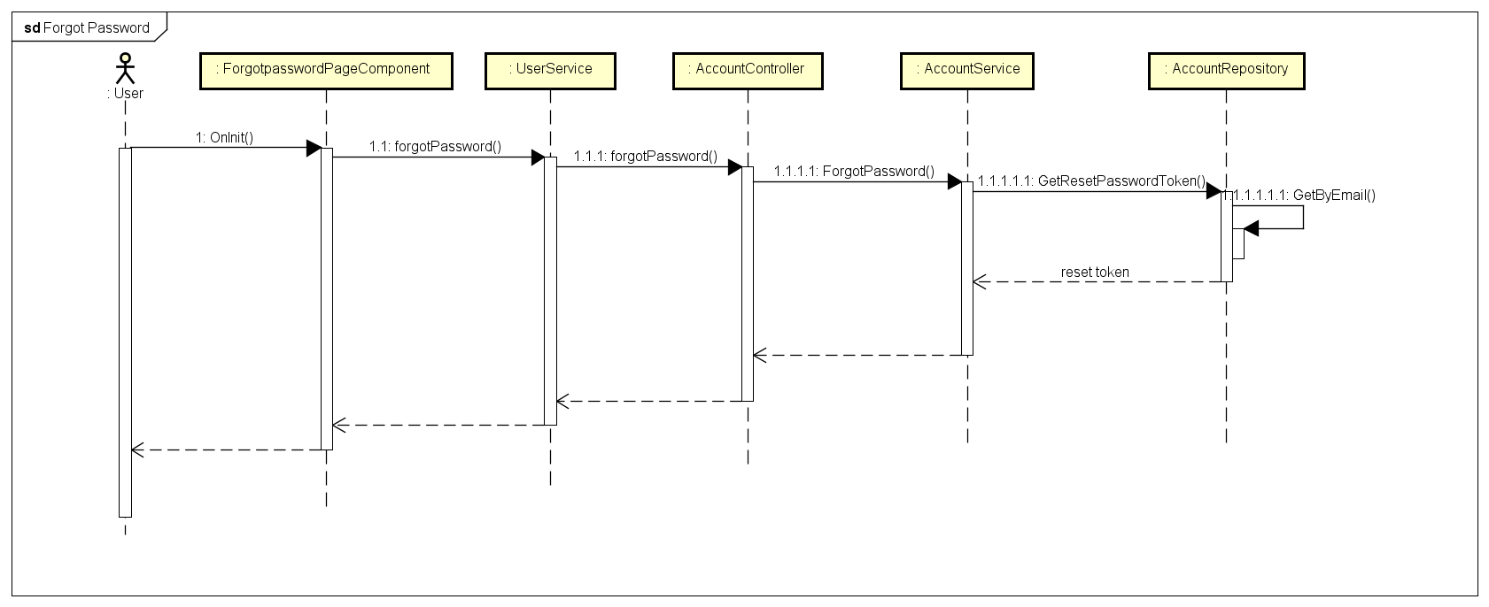

*Figure 4-34: Forgot Password Sequence Diagram*

* + - 1. **Sign-out**

**Screen Design**

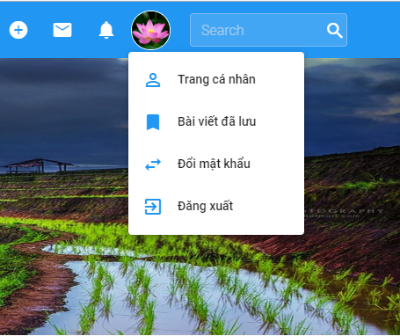

*Figure 4-35: Sign-out Screen Design*

**Class Diagram**

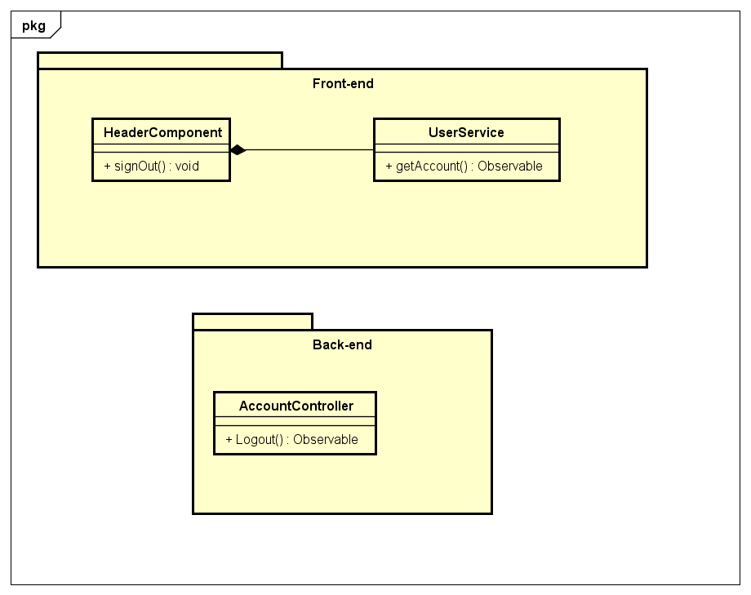

*Figure 4-36: Sign-out Class Diagram*

**Class Specification**

***HeaderComponent***

|  |  |  |  |
| --- | --- | --- | --- |
| **HeaderComponent** | | | |
| Physical address | src\app\core\components\header\ header.component.ts | | |
| Base Class | Class | | |
| **Attributes** | | | |
|  |  |  |  |
| **Operations** | | | |
| No | Name | Return Type | Description |
| 1 | signOut | void |  |

***UserService***

|  |  |  |  |
| --- | --- | --- | --- |
| **UserService** | | | |
| Physical address | src\app\core\services\user-service\user.service.ts | | |
| Base Class | Class | | |
| **Attributes** | | | |
| No | Name | Type | Description |
| 1 | apiUrl |  |  |
| **Operations** | | | |
| No | Name | Return Type | Description |
| 1 | getAccount | Observable |  |

***AccountController***

|  |  |  |  |
| --- | --- | --- | --- |
| **AccountController** | | | |
| Physical address | \src\Services\IdentityProvider\IdentityProvider\Controllers\  AccountController.cs | | |
| Base Class | Class | | |
| **Attributes** | | | |
| No | Name | Type | Description |
|  |  |  |  |
| **Operations** | | | |
| No | Name | Return Type | Description |
| 1 | Logout | Observable |  |

**Sequence Diagram**

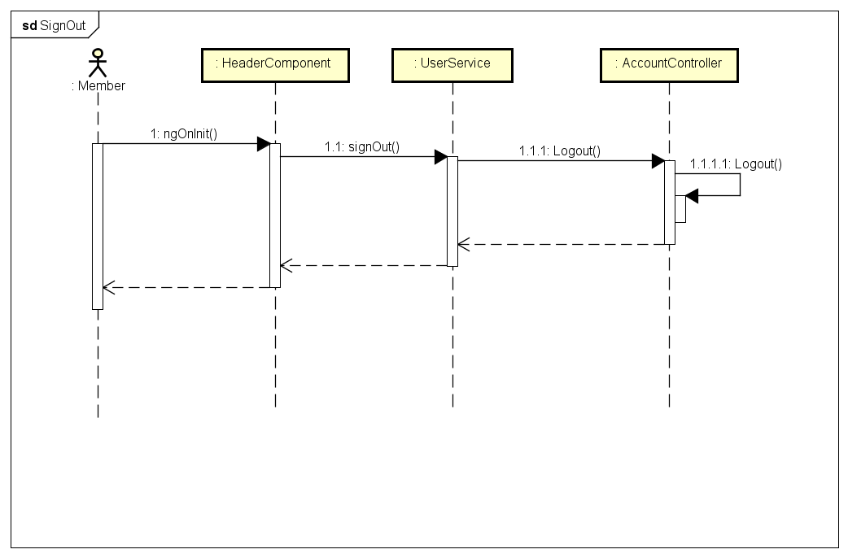

*Figure 4-37: Sign-out Sequence Diagram*

* + - 1. **Change Password**

**Screen Design**

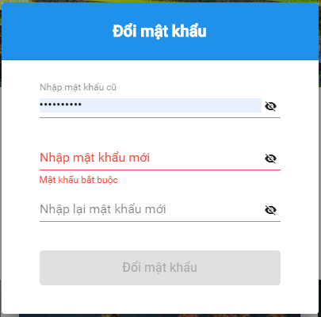

*Figure 4-38: Change Password Screen Design*

**Class Diagram**

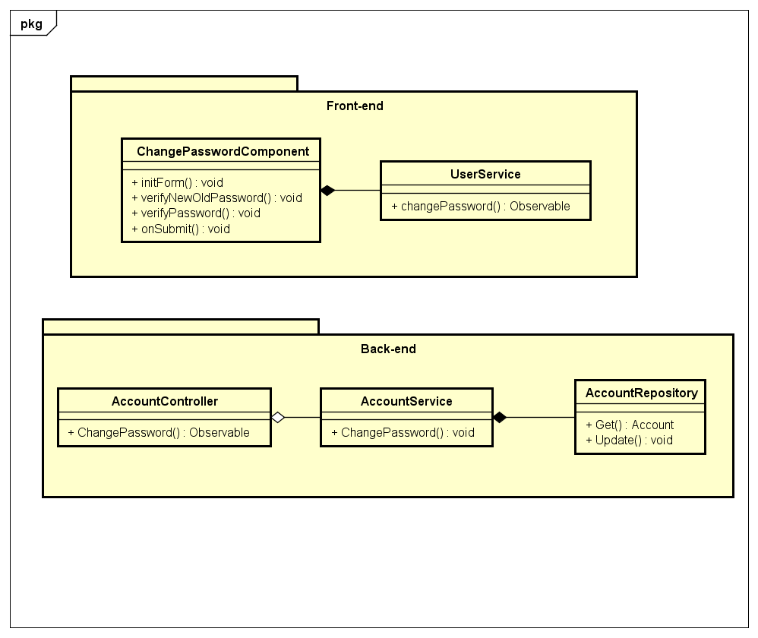

*Figure 4-39: Change Password Class Diagram*

**Class Specification**

***ChangePasswordComponent***

|  |  |  |  |
| --- | --- | --- | --- |
| **ChangePasswordComponent** | | | |
| Physical address | \src\app\shared\components\change-password\change-password.component.ts | | |
| Base Class | Class | | |
| **Attributes** | | | |
|  |  |  |  |
| **Operations** | | | |
| No | Name | Return Type | Description |
| 1 | initForm | void |  |
| 2 | verifyNewOldPassword | void |  |
| 3 | verifyPassword | void |  |
| 4 | onSubmit | void |  |

***UserService***

|  |  |  |  |
| --- | --- | --- | --- |
| **UserService** | | | |
| Physical address | src\app\core\services\user-service\user.service.ts | | |
| Base Class | Class | | |
| **Attributes** | | | |
| No | Name | Type | Description |
|  |  |  |  |
| **Operations** | | | |
| No | Name | Return Type | Description |
| 1 | changePassword | Observable |  |

***AccountController***

|  |  |  |  |
| --- | --- | --- | --- |
| **AccountController** | | | |
| Physical address | \src\Services\IdentityProvider\IdentityProvider\Controllers\  AccountController.cs | | |
| Base Class | Class | | |
| **Attributes** | | | |
| No | Name | Type | Description |
|  |  |  |  |
| **Operations** | | | |
| No | Name | Return Type | Description |
| 1 | ChangePassword | Observable |  |

***AccountService***

|  |  |  |  |
| --- | --- | --- | --- |
| **AccountService** | | | |
| Physical address | \src\Services\IdentityProvider\IdentityProvider\Services\AccountService.cs | | |
| Base Class | Class | | |
| **Attributes** | | | |
| No | Name | Type | Description |
|  |  |  |  |
| **Operations** | | | |
| No | Name | Return Type | Description |
| 1 | ChangePassword | void |  |

***AccountRepository***

|  |  |  |  |
| --- | --- | --- | --- |
| **AccountRepository** | | | |
| Physical address | \src\Services\IdentityProvider\IdentityProvider\Repositories\AccountRepository.cs | | |
| Base Class | Class | | |
| **Attributes** | | | |
| No | Name | Type | Description |
|  |  |  |  |
| **Operations** | | | |
| No | Name | Return Type | Description |
| 1 | Get | Account |  |
| 2 | Update | Account |  |

**Sequence Diagram**

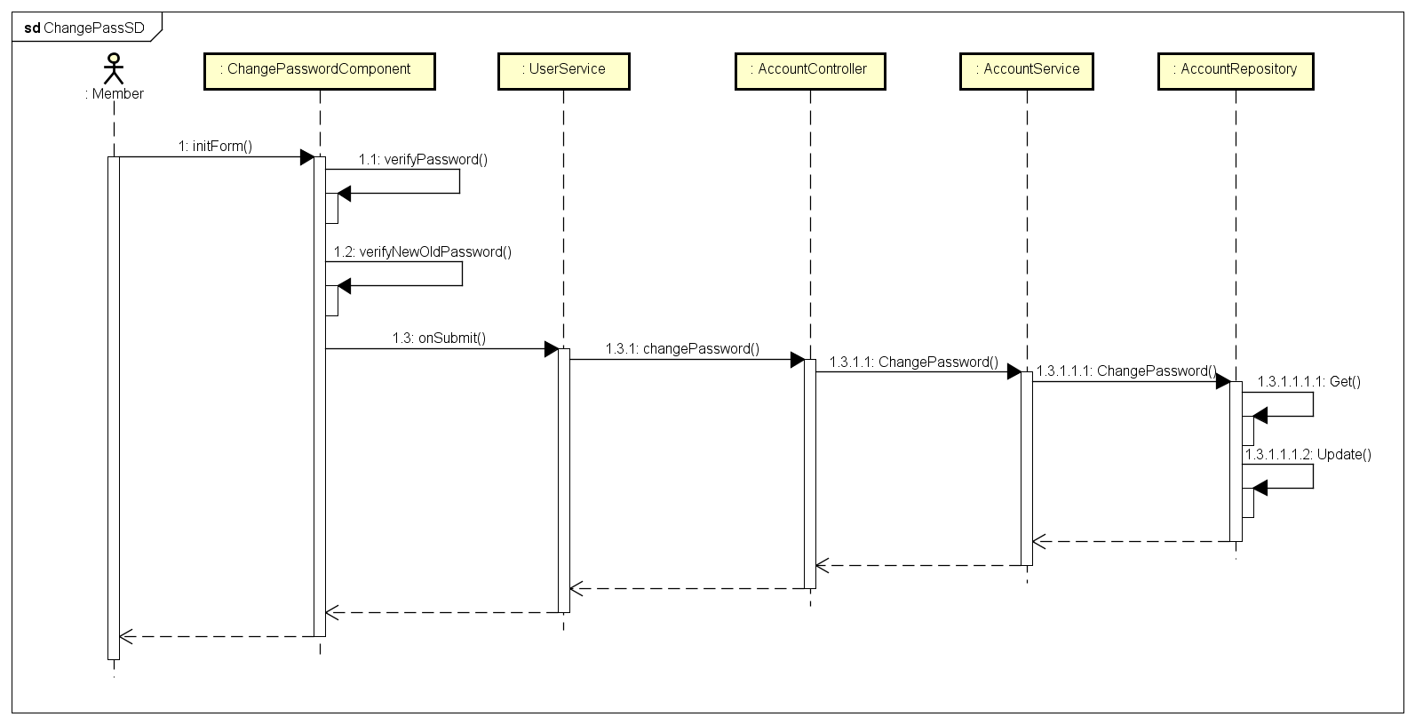

*Figure 4-40: Change Password Sequence Diagram*

* + - 1. **Update Profile**

**Screen Design**

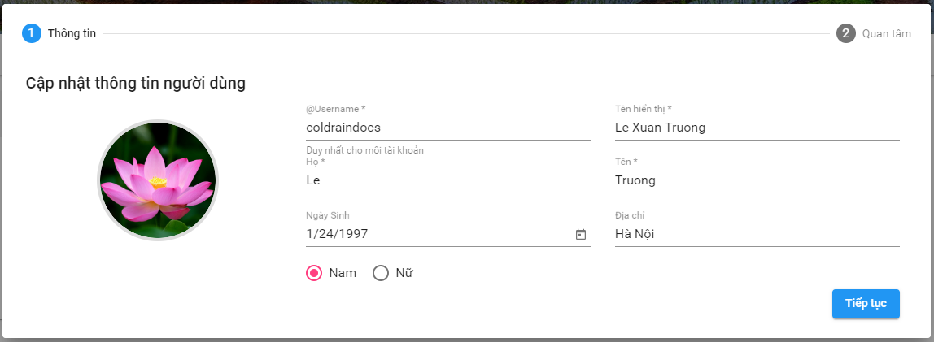

*Figure 4-41: Update Profile Screen Design*

**Class Diagram**

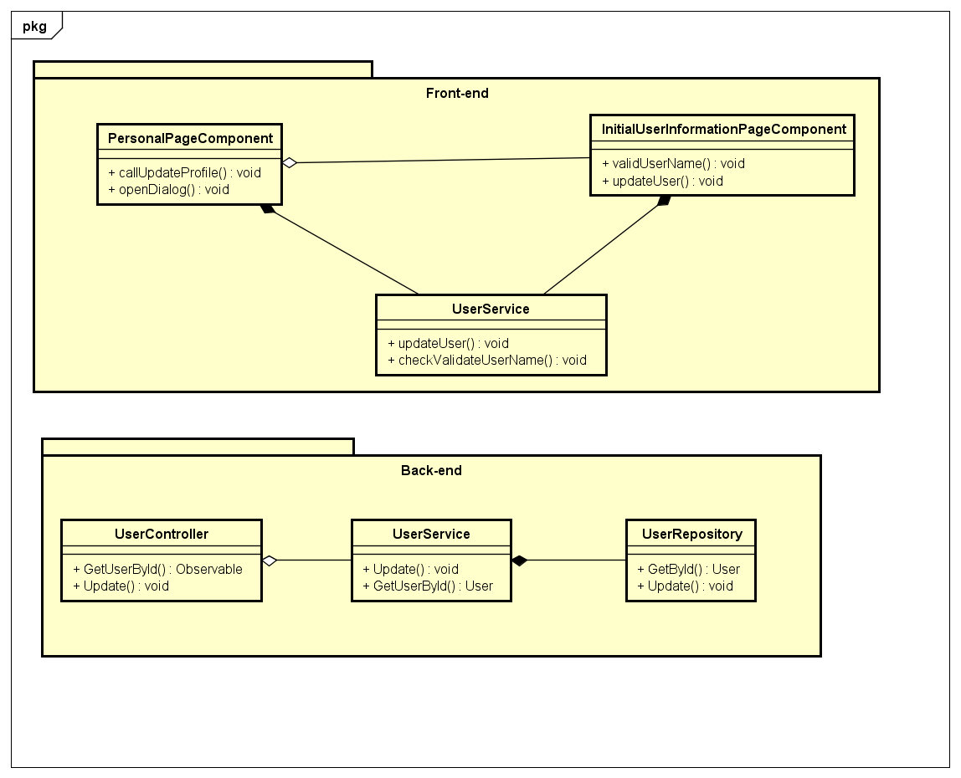

*Figure 4-42: Update Profile Class Diagram*

**Class Specification**

***PersonalPageComponent***

|  |  |  |  |
| --- | --- | --- | --- |
| **PersonalPageComponent** | | | |
| Physical address | src\app\pages\personal-page\ personal-page.component.ts | | |
| Base Class | Class | | |
| **Attributes** | | | |
|  |  |  |  |
| **Operations** | | | |
| No | Name | Return Type | Description |
| 1 | callUpdateProfile | void |  |
| 2 | openDialog | void |  |

***InitialUserInformationPageComponent***

|  |  |  |  |
| --- | --- | --- | --- |
| **InitialUserInformationPageComponent** | | | |
| Physical address | src\app\pages\initial-user-information-page\initial-user-information-page.component.ts | | |
| Base Class | Class | | |
| **Attributes** | | | |
|  |  |  |  |
| **Operations** | | | |
| No | Name | Return Type | Description |
| 1 | validUserName | void |  |
| 2 | updateUser | void |  |

***UserService***

|  |  |  |  |
| --- | --- | --- | --- |
| **UserService** | | | |
| Physical address | src\app\core\services\user-service\user.service.ts | | |
| Base Class | Class | | |
| **Attributes** | | | |
| No | Name | Type | Description |
|  |  |  |  |
| **Operations** | | | |
| No | Name | Return Type | Description |
| 1 | checkValidateUserName | Observable |  |
| 2 | updateUser | Observable |  |

***UserController***

|  |  |  |  |
| --- | --- | --- | --- |
| **UserController** | | | |
| Physical address | \src\Services\UserService\UserService\Controllers\UserController.cs | | |
| Base Class | Class | | |
| **Attributes** | | | |
| No | Name | Type | Description |
|  |  |  |  |
| **Operations** | | | |
| No | Name | Return Type | Description |
| 1 | GetUserById | Observable |  |
| 2 | Update | Observable |  |

***UserService (back-end)***

|  |  |  |  |
| --- | --- | --- | --- |
| **UserService** | | | |
| Physical address | \src\Services\UserService\UserService\Services\UserService.cs | | |
| Base Class | Class | | |
| **Attributes** | | | |
| No | Name | Type | Description |
|  |  |  |  |
| **Operations** | | | |
| No | Name | Return Type | Description |
| 1 | GetUserById | User |  |
| 2 | Update | void |  |

***UserRepository***

|  |  |  |  |
| --- | --- | --- | --- |
| **UserRepository** | | | |
| Physical address | \src\Services\UserService\UserService\Reponsitories\UserRepository.cs | | |
| Base Class | Class | | |
| **Attributes** | | | |
| No | Name | Type | Description |
|  |  |  |  |
| **Operations** | | | |
| No | Name | Return Type | Description |
| 1 | GetById | User |  |
| 2 | Update | void |  |

**Sequence Diagram**

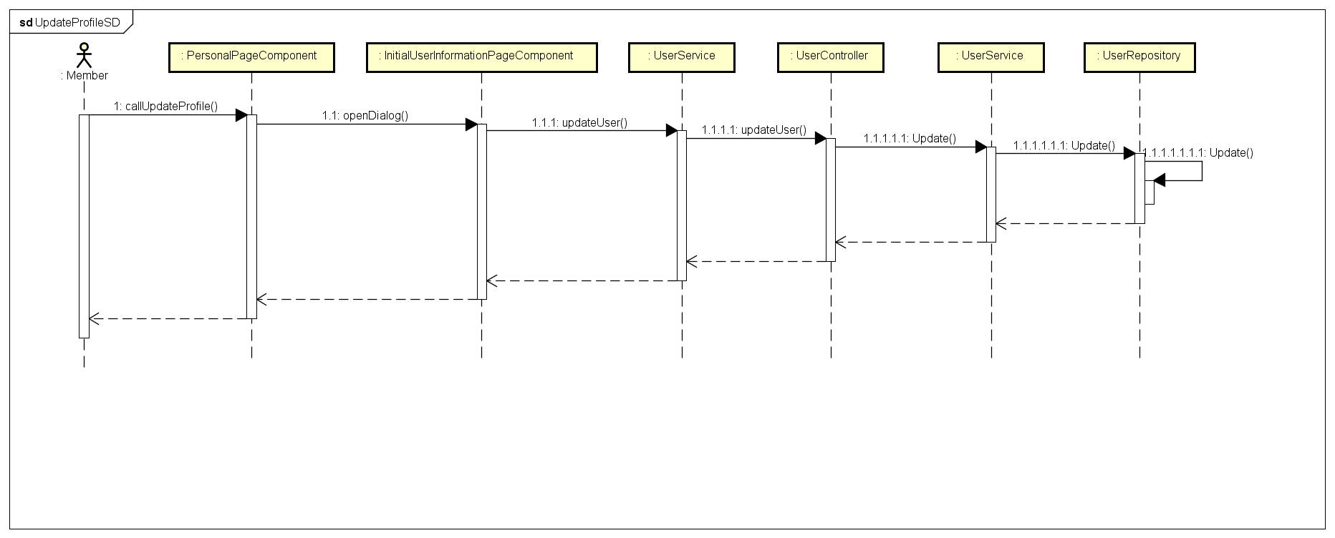

*Figure 4-43: Update Profile Sequence Diagram*

* + - 1. **Choose Interested Topic**

**Screen Design**

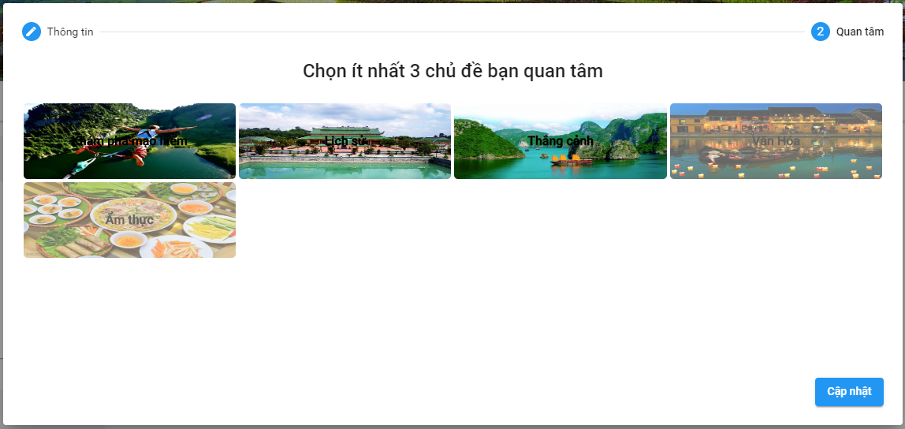

*Figure 4-44: Choose Interested Topic*

**Class Diagram**

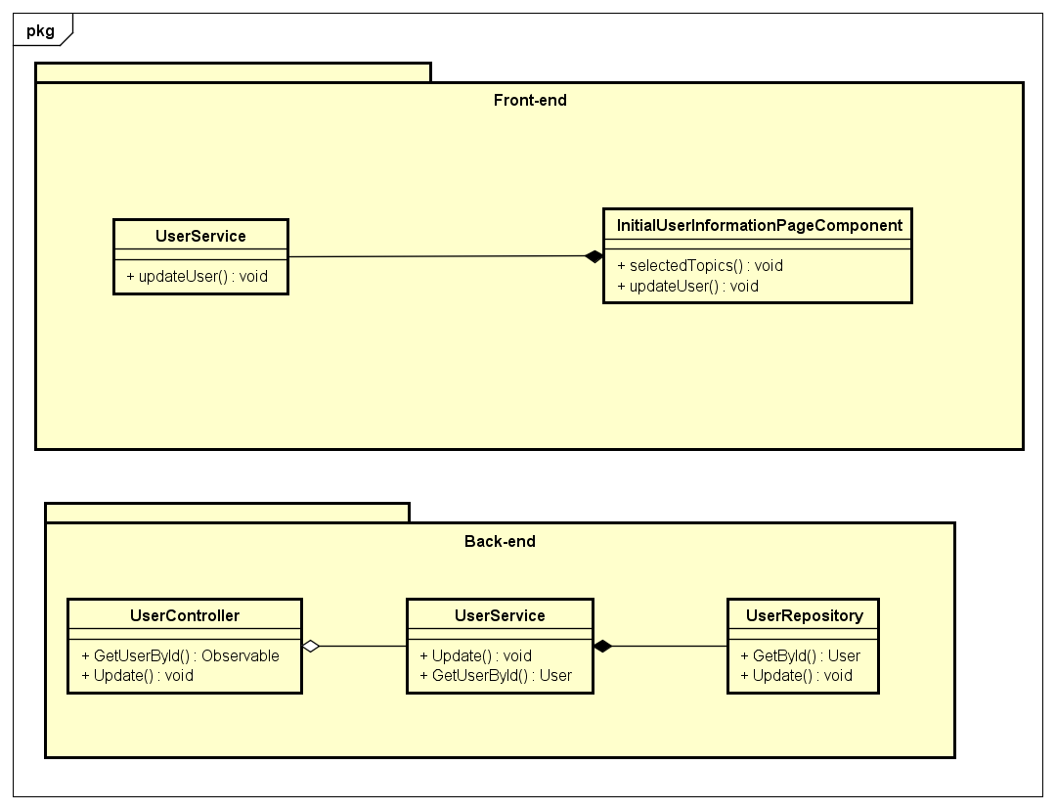

*Figure 4-45: Choose Interested Topic Class Diagram*

**Class Specification**

***InitialUserInformationPageComponent***

|  |  |  |  |
| --- | --- | --- | --- |
| **InitialUserInformationPageComponent** | | | |
| Physical address | src\app\pages\initial-user-information-page\initial-user-information-page.component.ts | | |
| Base Class | Class | | |
| **Attributes** | | | |
|  |  |  |  |
| **Operations** | | | |
| No | Name | Return Type | Description |
| 1 | selectedTopics | void |  |
| 2 | updateUser | void |  |

***UserService***

|  |  |  |  |
| --- | --- | --- | --- |
| **UserService** | | | |
| Physical address | src\app\core\services\user-service\user.service.ts | | |
| Base Class | Class | | |
| **Attributes** | | | |
| No | Name | Type | Description |
|  |  |  |  |
| **Operations** | | | |
| No | Name | Return Type | Description |
| 1 | updateUser | Observable |  |

***UserController***

|  |  |  |  |
| --- | --- | --- | --- |
| **UserController** | | | |
| Physical address | \src\Services\UserService\UserService\Controllers\UserController.cs | | |
| Base Class | Class | | |
| **Attributes** | | | |
| No | Name | Type | Description |
|  |  |  |  |
| **Operations** | | | |
| No | Name | Return Type | Description |
| 1 | GetUserById | Observable |  |
| 2 | Update | Observable |  |

***UserService (back-end)***

|  |  |  |  |
| --- | --- | --- | --- |
| **UserService** | | | |
| Physical address | \src\Services\UserService\UserService\Services\UserService.cs | | |
| Base Class | Class | | |
| **Attributes** | | | |
| No | Name | Type | Description |
|  |  |  |  |
| **Operations** | | | |
| No | Name | Return Type | Description |
| 1 | GetUserById | User |  |
| 2 | Update | void |  |

***UserRepository***

|  |  |  |  |
| --- | --- | --- | --- |
| **UserRepository** | | | |
| Physical address | \src\Services\UserService\UserService\Reponsitories\UserRepository.cs | | |
| Base Class | Class | | |
| **Attributes** | | | |
| No | Name | Type | Description |
|  |  |  |  |
| **Operations** | | | |
| No | Name | Return Type | Description |
| 1 | GetById | User |  |
| 2 | Update | void |  |

**Sequence Diagram**

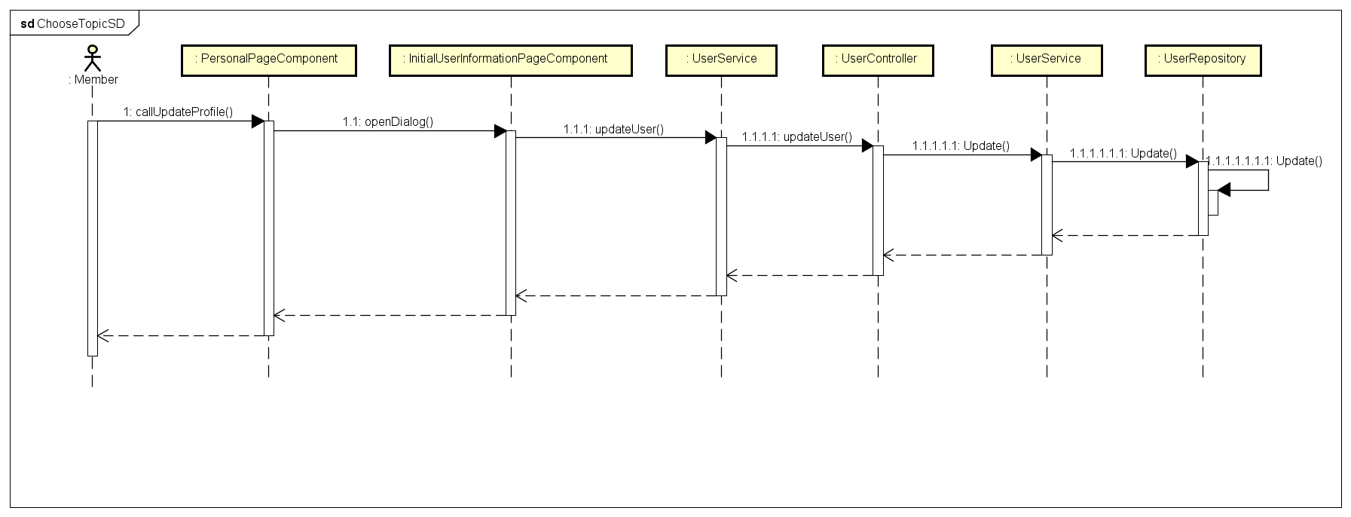

*Figure 4-46: Choose Interested Topic Sequence Diagram*

* + - 1. **Create A Post**

**Screen Design**

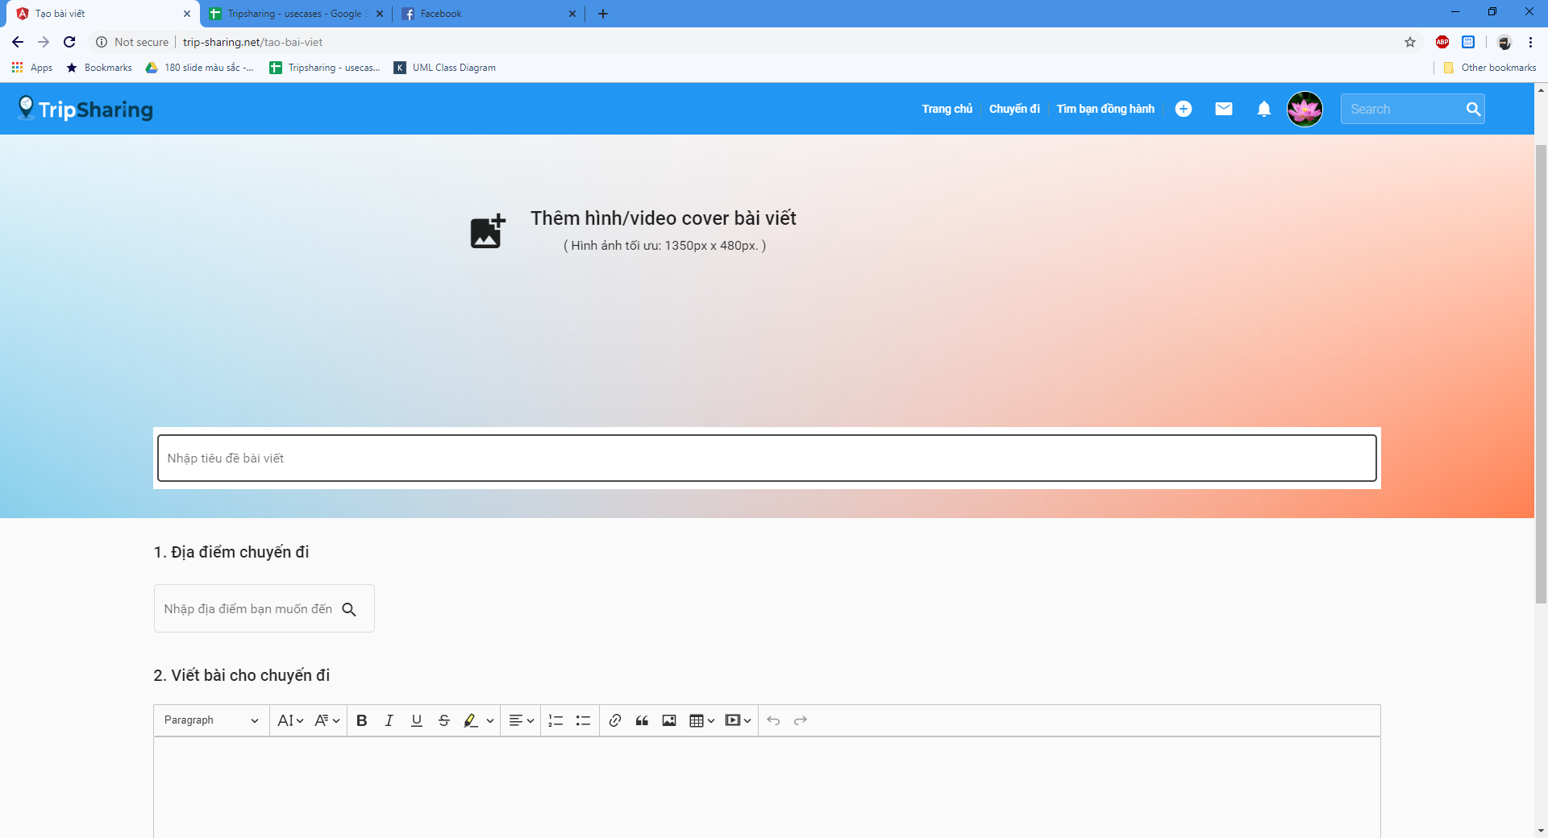

*Figure 4-47: Create A Post Screen Design*

**Class Diagram**

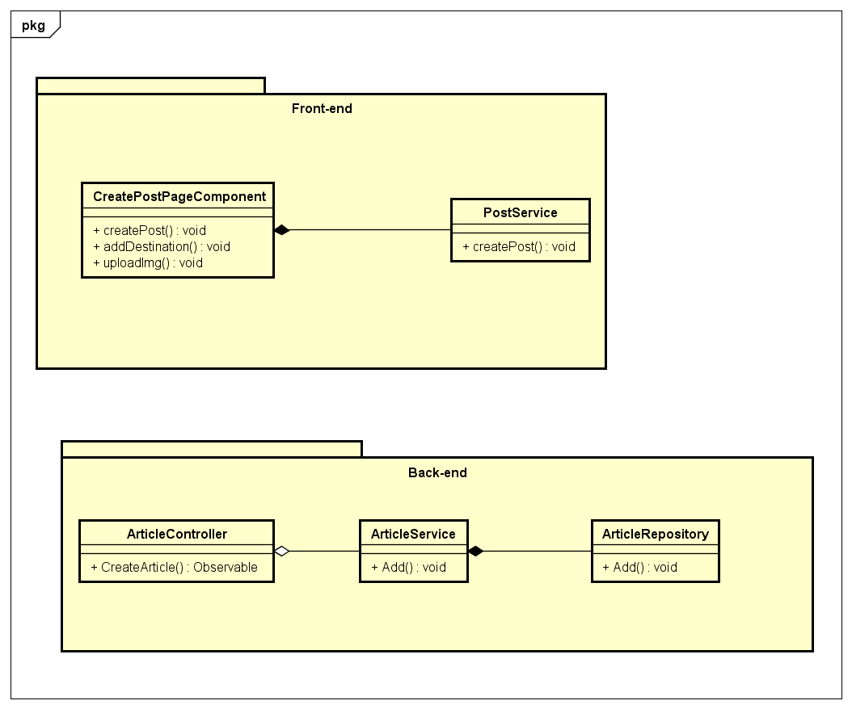

*Figure 4-48: Create A Post Class Diagram*

**Class Specification**

***CreatePostPageComponent***

|  |  |  |  |
| --- | --- | --- | --- |
| **CreatePostPageComponent** | | | |
| Physical address | src\app\pages\create-post-page\ create-post-page.component.ts | | |
| Base Class | Class | | |
| **Attributes** | | | |
|  |  |  |  |
| **Operations** | | | |
| No | Name | Return Type | Description |
| 1 | createPost | void |  |
| 2 | addDestination | void | User must choose a destination |
| 3 | uploadImg | void | Upload image |

***UserService***

|  |  |  |  |
| --- | --- | --- | --- |
| **UserService** | | | |
| Physical address | src\app\core\services\user-service\user.service.ts | | |
| Base Class | Class | | |
| **Attributes** | | | |
| No | Name | Type | Description |
|  |  |  |  |
| **Operations** | | | |
| No | Name | Return Type | Description |
| 1 | createPost | Observable |  |

***ArticleController***

|  |  |  |  |
| --- | --- | --- | --- |
| **ArticleController** | | | |
| Physical address | src\Services\PostService\PostService\Controllers\ArticleController.cs | | |
| Base Class | Class | | |
| **Attributes** | | | |
| No | Name | Type | Description |
|  |  |  |  |
| **Operations** | | | |
| No | Name | Return Type | Description |
| 1 | CreateArticle | Observable |  |

***ArticleService***

|  |  |  |  |
| --- | --- | --- | --- |
| **ArticleService** | | | |
| Physical address | src\Services\PostService\PostService\Services\ArticleService.cs | | |
| Base Class | Class | | |
| **Attributes** | | | |
| No | Name | Type | Description |
|  |  |  |  |
| **Operations** | | | |
| No | Name | Return Type | Description |
| 1 | Add | User |  |

***ArticleRepository***

|  |  |  |  |
| --- | --- | --- | --- |
| **ArticleRepository** | | | |
| Physical address | src\Services\PostService\PostService\Repositories\ArticleRepository.cs | | |
| Base Class | Class | | |
| **Attributes** | | | |
| No | Name | Type | Description |
|  |  |  |  |
| **Operations** | | | |
| No | Name | Return Type | Description |
| 1 | Add | void |  |

**Sequence Diagram**

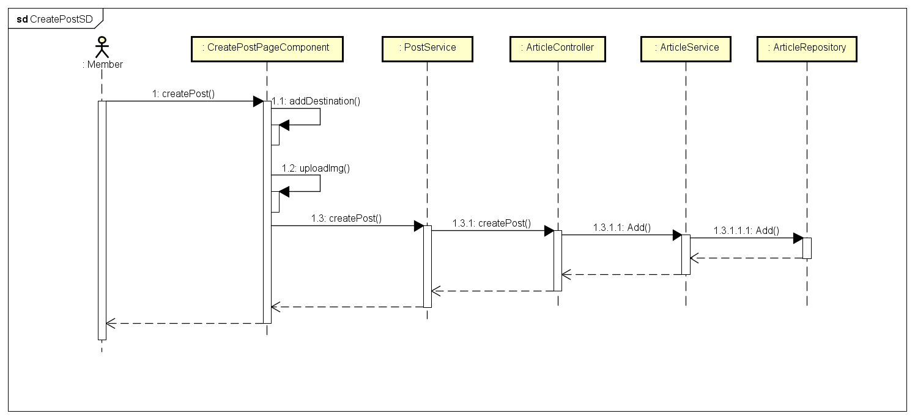

*Figure 4-49: Create A Post Sequence Diagram*

* + - 1. **Edit A Post**

**Screen Design**

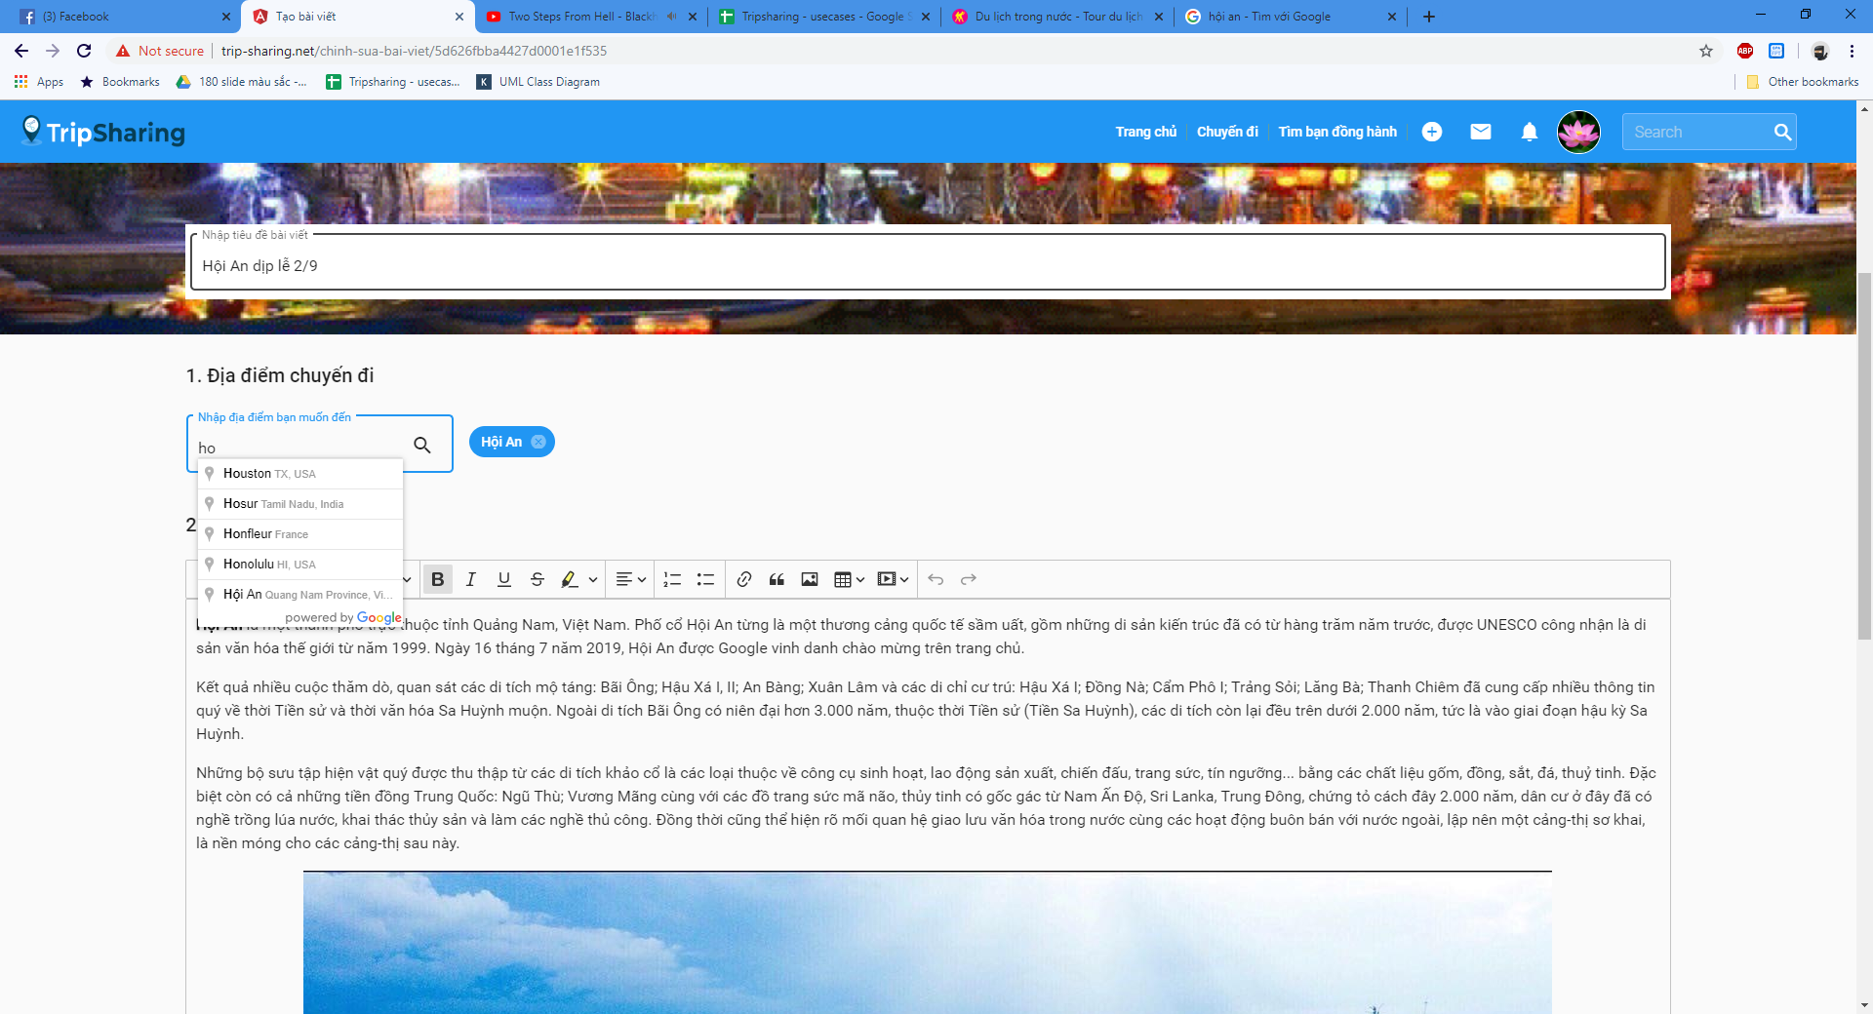

*Figure 4-50: Edit A Post Sequence Diagram*

**Class Diagram**

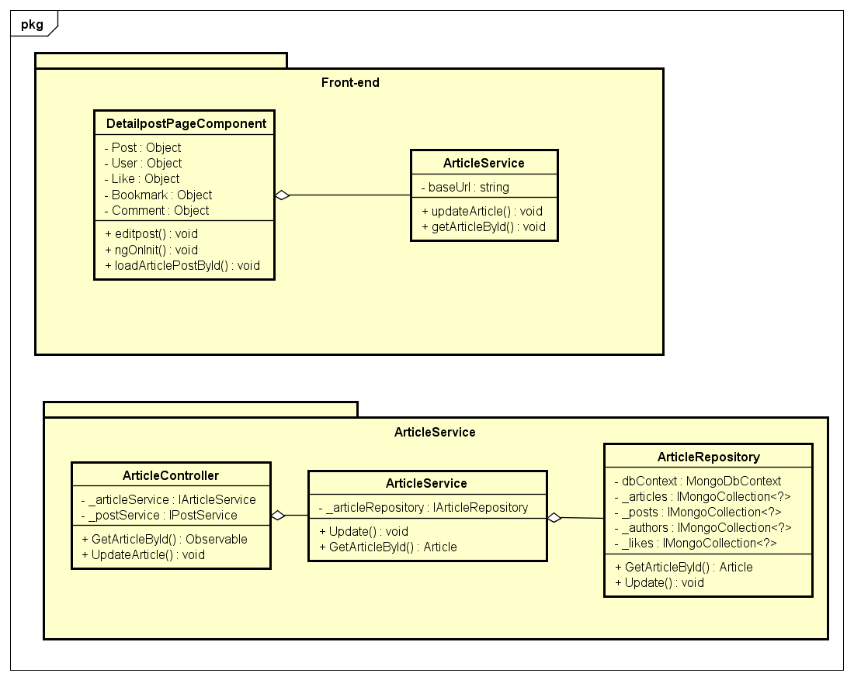

*Figure 4-51: Edit A Post Class Diagram*

**Class Specification**

***DetailpostPageComponent***

|  |  |  |  |
| --- | --- | --- | --- |
| **DetailpostPageComponent** | | | |
| Physical address | src\app\pages\detailpost-page\detailpost-page.component.ts | | |
| Base Class | Class | | |
| **Attributes** | | | |
| No | Name | Type | Description |
| 1 | Post | Object | Instance of Post object |
| 2 | User | Object | Instance of User object |
| 3 | Like | Object | Instance of Like object |
| 4 | Bookmark | Object | Instance of Bookmark object |
| 5 | Comment | Object | Instance of Comment object |
| **Operations** | | | |
| No | Name | Return Type | Description |
| 1 | editpost | void |  |
| 2 | ngOnInit | void |  |
| 3 | loadArticlePostById | void |  |

***PostService***

|  |  |  |  |
| --- | --- | --- | --- |
| **PostService** | | | |
| Physical address | src\app\core\services\post-service\post.service.ts | | |
| Base Class | Class | | |
| **Attributes** | | | |
| No | Name | Type | Description |
| 1 | baseUrl | String |  |
| **Operations** | | | |
| No | Name | Return Type | Description |
| 1 | getArticleById | Article |  |
| 2 | updateArticle | Void |  |

***ArticleController***

|  |  |  |  |
| --- | --- | --- | --- |
| **ArticleController** | | | |
| Physical address | src\Services\PostService\PostService\Controllers\ArticleController.cs | | |
| Base Class | Class | | |
| **Attributes** | | | |
| No | Name | Type | Description |
| 1 | _articleService | IArticleService |  |
| 2 | _postService | IPostService |  |
| **Operations** | | | |
| No | Name | Return Type | Description |
| 1 | GetArticleById | Observable |  |
| 2 | UpdateArticle | Void |  |

***ArticleService***

|  |  |  |  |
| --- | --- | --- | --- |
| **ArticleService** | | | |
| Physical address | src\Services\PostService\PostService\Services\ArticleService.cs | | |
| Base Class | Class | | |
| **Attributes** | | | |
| No | Name | Type | Description |
| 1 | _articleService | IArticleService |  |
| 2 | _postService | IPostService |  |
| **Operations** | | | |
| No | Name | Return Type | Description |
| 1 | GetArticleById | Article |  |
| 2 | Update | Void |  |

***ArticleRepository***

|  |  |  |  |
| --- | --- | --- | --- |
| **ArticleRepository** | | | |
| Physical address | src\Services\PostService\PostService\Repositories\ArticleRepository.cs | | |
| Base Class | Class | | |
| **Attributes** | | | |
| No | Name | Type | Description |
| 1 | dbContext | MongoDbContext |  |
| 2 | _articles | IMongoCollection<?> |  |
| 3 | _posts | IMongoCollection<?> |  |
| 4 | _authors | IMongoCollection<?> |  |
| 5 | _likes | IMongoCollection<?> |  |
| **Operations** | | | |
| No | Name | Return Type | Description |
| 1 | GetArticleById | Article |  |
| 2 | Update | Void |  |

**Sequence Diagram**

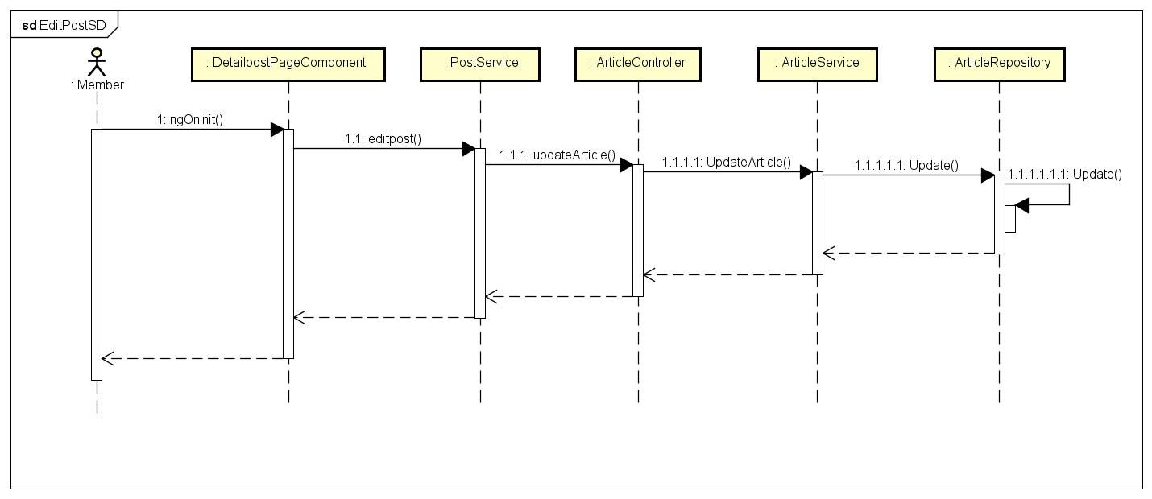

*Figure 4-52: Edit A Post Sequence Diagram*

**4.3.4.12 Delete A Post**

**Screen Design**

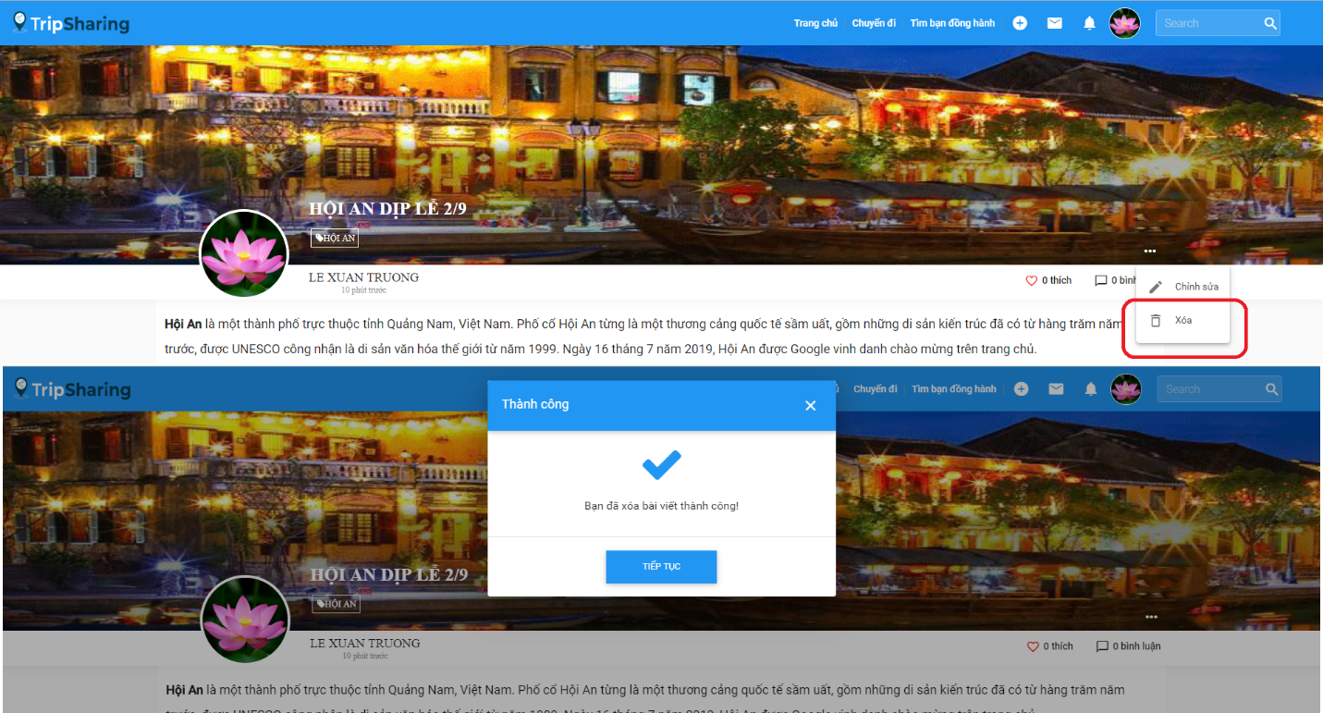

*Figure 4-53: Delete A Post Screen Design*

**Class Diagram**

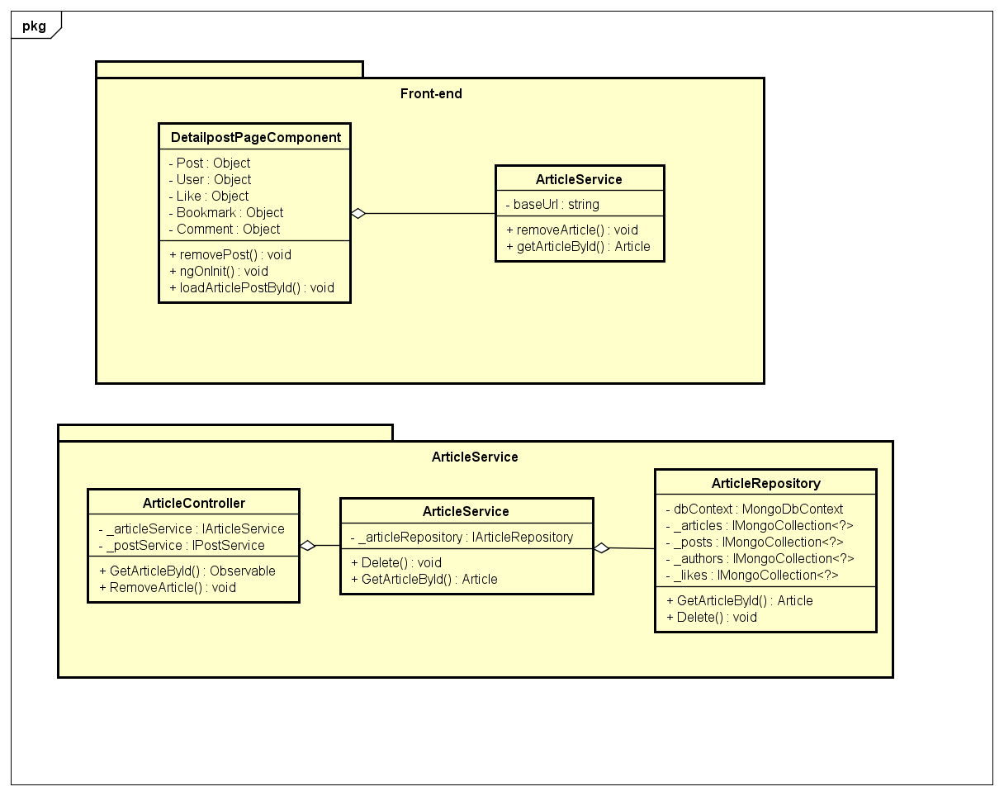

*Figure 4-53: Delete A Post Class Diagram*

**Class Specification**

***DetailpostPageComponent***

|  |  |  |  |
| --- | --- | --- | --- |
| **DetailpostPageComponent** | | | |
| Physical address | src\app\pages\detailpost-page\detailpost-page.component.ts | | |
| Base Class | Class | | |
| **Attributes** | | | |
| No | Name | Type | Description |
| 1 | Post | Object | Instance of Post object |
| 2 | User | Object | Instance of User object |
| 3 | Like | Object | Instance of Like object |
| 4 | Bookmark | Object | Instance of Bookmark object |
| 5 | Comment | Object | Instance of Comment object |
| **Operations** | | | |
| No | Name | Return Type | Description |
| 1 | removePost | void |  |
| 2 | ngOnInit | void |  |
| 3 | loadArticlePostById | void |  |

***PostService***

|  |  |  |  |
| --- | --- | --- | --- |
| **PostService** | | | |
| Physical address | src\app\core\services\post-service\post.service.ts | | |
| Base Class | Class | | |
| **Attributes** | | | |
| No | Name | Type | Description |
| 1 | baseUrl | String |  |
| **Operations** | | | |
| No | Name | Return Type | Description |
| 1 | getArticleById | Article |  |
| 2 | removeArticle | Void |  |

***ArticleController***

|  |  |  |  |
| --- | --- | --- | --- |
| **ArticleController** | | | |
| Physical address | src\Services\PostService\PostService\Controllers\ArticleController.cs | | |
| Base Class | Class | | |
| **Attributes** | | | |
| No | Name | Type | Description |
| 1 | _articleService | IArticleService |  |
| 2 | _postService | IPostService |  |
| **Operations** | | | |
| No | Name | Return Type | Description |
| 1 | GetArticleById | Observable |  |
| 2 | RemoveArticle | Void |  |

***ArticleService***

|  |  |  |  |
| --- | --- | --- | --- |
| **ArticleService** | | | |
| Physical address | src\Services\PostService\PostService\Services\ArticleService.cs | | |
| Base Class | Class | | |
| **Attributes** | | | |
| No | Name | Type | Description |
| 1 | _articleService | IArticleService |  |
| 2 | _postService | IPostService |  |
| **Operations** | | | |
| No | Name | Return Type | Description |
| 1 | GetArticleById | Article |  |
| 2 | Delete | Void |  |

***ArticleRepository***

|  |  |  |  |
| --- | --- | --- | --- |
| **ArticleRepository** | | | |
| Physical address | src\Services\PostService\PostService\Repositories\ArticleRepository.cs | | |
| Base Class | Class | | |
| **Attributes** | | | |
| No | Name | Type | Description |
| 1 | dbContext | MongoDbContext |  |
| 2 | _articles | IMongoCollection<?> |  |
| 3 | _posts | IMongoCollection<?> |  |
| 4 | _authors | IMongoCollection<?> |  |
| 5 | _likes | IMongoCollection<?> |  |
| **Operations** | | | |
| No | Name | Return Type | Description |
| 1 | GetArticleById | Article |  |
| 2 | Delete | Void |  |

**Sequence Diagram**

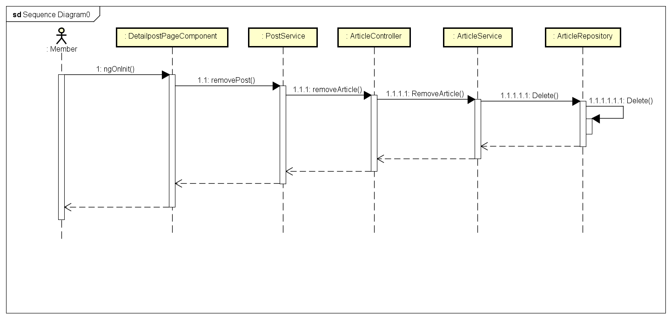

*Figure 4-54: Delete A Post Sequence Diagram*

* + - 1. **Like/Unlike A Post**

**Screen Design**

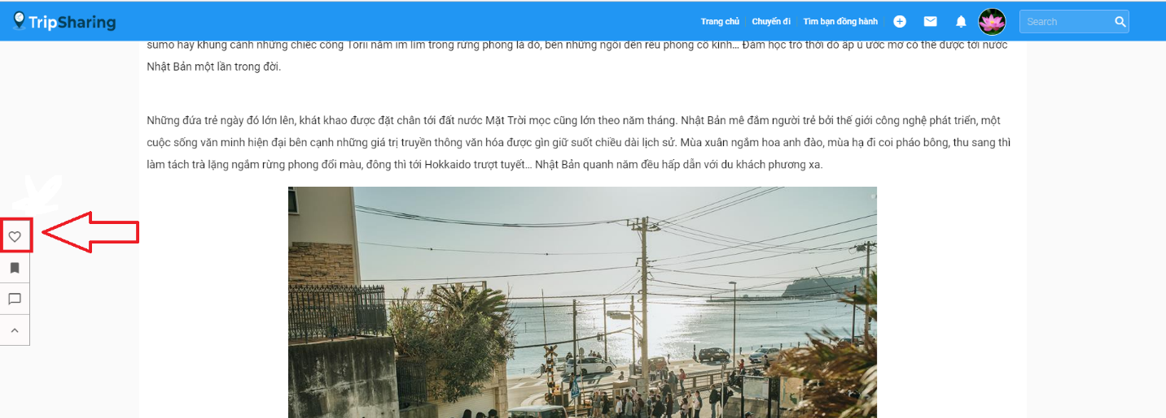

*Figure 4-55: Like/Unlike A Post Screen Design*

**Class Diagram**